

3, Menara Sentral, Penang Street, 10200 Penang. Tel: 04-2621888

|  |  |
| --- | --- |
| **Student Name** | **YAP KOO WEI** |
| **Student ID** | **SC01230175DC** |
| **Course Code & Name** | **EFP3514 FINAL YEAR PROJECT** |
| **Project Title** | **WINDY AUTOS ENTERPRISE INFORMATION SYSTEM** |
| **Supervisor** | **MR SHAHRIL** |
| **Semester / Year** | **JANUARY 2025** |

**(*This completed cover sheet must be attached to the front of your assignment)***

**Plagiarism**

**Plagiarism is the misrepresentation of the work of others as one's own (including ideas, arguments, words, diagrams, images or data). It includes the explicit claim that another person's work as one's own and the failure to adequately acknowledge the sources used. Plagiarism is an academic misconduct and will be penalised accordingly.**

**Declaration**

**I certify that this assignment is a result of my own independent work and investigation. The use of material from other sources has been properly and fully acknowledged in this assignment. A bibliography is appended. I fully understand the consequence of committing plagiarism, and if proven and in the absence if mitigating circumstances, it could include failure in the Year or part of my course or even withdrawal from the program.**

**I declare that this assignment is in full compliance of the above requirements.**

**Signature: Date: 6 JANUARY 2025**

* **To score high marks, you must meet the requirements outlined in the assessment criteria.**
* **Late submission might result in mark deduction of marks.**

**WINDY AUTOS ENTERPRISE INFORMATION SYSTEM**

**YAP KOO WEI (SC01230175DC)**

**Report Submitted to Fulfil the Partial Requirements for the Diploma in Computer Systems Technology**

**SENTRAL College Penang**

# Table of Contents

**Chapter 1.0 Introduction (5 – 7)**

* 1. Project Overview
  2. Company Background
  3. Problem Statement
  4. Project Objectives

**Chapter 2.0 System Planning (8 – 10)**

* 1. Feasibility Analysis
  2. Project Plan
  3. Project Schedule

**Chapter 3.0 System Analysis and Design (11 – 30)**

* 1. Requirement Gathering
  2. Flow Chart
  3. Context Diagram
  4. Data Flow Diagram
  5. Data Dictionary
  6. Database Design
  7. Interface Design

**Chapter 4.0 System Development (31 – 50)**

* 1. System Use Case
  2. Database
  3. Validation and Verification
  4. Program Code
  5. User Interface

**Chapter 5.0 Testing and Future Enhancement (51 – 52)**

* 1. Testing
  2. Future Enhancements

**Chapter 6.0 Conclusion (53 – 54)**

**Chapter 7.0 References (55)**

**Chapter 8.0 Appendix (56 - 72)**

## Chapter 1.0 Introduction

#### Project Overview

This report details the development of an enterprise software solution designed for Windy Autos, a used car dealership owned and operated by Mr. Ng. The primary goal of this system is to streamline business operations by digitizing record-keeping and transaction management. The software includes features for managing car inventory, customer data, and transaction records, all within a secure, user-authenticated environment. By implementing this system, the aim is to reduce the workload on Mr. Ng, who currently handles all administrative tasks manually, and to minimize errors that are common with traditional paper-based methods. The system will also generate reports based on transaction history,

providing Mr. Ng with better insight into business performance. While primarily designed for Mr. Ng’s use, the system includes an account management feature, which allows for different user roles, should additional employees ever be introduced to the business in the future.

#### Company Background

Windy Autos is a small-scale used car dealership located in Bukit Mertajam. The business was founded in 2015 by Mr. Ng, who, despite having no prior background in automotive sales, relied on his ability to communicate effectively with customers to establish and maintain a steady flow of business. The dealership operates daily from 9 AM to 9 PM, offering customers the option to either purchase vehicles outright with cash or secure financing through a partnered bank, with an optional add-on for insurance.

Mr. Ng is the sole proprietor and the only employee, handling everything from customer interactions to administrative work. Over the years, he has relied on traditional methods of record-keeping, such as notebooks and physical files, which have become increasingly cumbersome as the business has grown. With a lack of formal training in technology, Mr. Ng has been hesitant to switch to a digital system but recognizes the inefficiencies in his current approach. He is now open to adopting a modern solution, provided that it remains simple to use and does not disrupt his established workflow.

#### Problem Statement

The primary issue faced by Windy Autos is the inefficiency of its existing administrative processes. Mr. Ng’s reliance on manual record-keeping has led to various challenges,

including misplaced records, calculation errors, and difficulty in retrieving past transactions. These inefficiencies not only consume valuable time but also increase the likelihood of mistakes that could impact business operations. Given that Mr. Ng is the sole worker, every moment spent on administrative tasks takes away from his primary strength—customer service.

Additionally, the lack of a structured database means that accessing information requires sifting through stacks of paperwork, which is both time-consuming and prone to oversight. There is also no streamlined way to generate reports or track business performance over time, making it difficult for Mr. Ng to make data-driven decisions. As the business continues to grow, these issues will only compound, making it imperative to transition to a digital system that can handle these tasks more efficiently.

#### Project Objectives

The objective of this project is to develop a software solution that addresses the challenges faced by Windy Autos. The system will provide an intuitive and user-friendly interface that allows Mr. Ng to manage his inventory, customer records, and transactions with minimal effort. By automating these processes, the software will reduce human error and free up time for Mr. Ng to focus on sales and customer interactions.

Key features of the system include user authentication, a structured database for managing cars and customers, automated transaction recording with self-filling fields, and the ability to generate invoices and reports. The reporting functionality will allow Mr. Ng to analyze business performance based on customizable criteria, giving him better insight into sales trends and operational efficiency.

Security is also a consideration, with user authentication ensuring that only authorized individuals can access and modify critical business data. While Mr. Ng is currently the only

user, the system is built with scalability in mind, allowing for additional users if the need arises in the future.

Ultimately, this project aims to modernize Windy Autos’ operations without imposing a steep learning curve on Mr. Ng. The system is designed to integrate seamlessly into his existing workflow, providing a practical and efficient alternative to his current manual processes.

## Chapter 2.0 System Planning

#### Feasibility Analysis

Before proceeding with the development of the system, a feasibility analysis was conducted to evaluate the strengths, weaknesses, opportunities, and threats associated with this project.

One of the primary strengths of the system is that it directly addresses the specific needs of Windy Autos. It is custom-built for Mr. Ng, meaning it includes only the features that are relevant to his business operations. This ensures a streamlined experience without unnecessary complexity. Additionally, automating administrative tasks reduces errors and increases efficiency, allowing Mr. Ng to focus on customer interactions.

However, the system does have certain weaknesses. Since Mr. Ng has no prior experience with digital record-keeping, there is a learning curve associated with transitioning to the new system. While the software is designed to be user-friendly, some initial training and adaptation will still be required. Another potential weakness is the reliance on technology—if the system encounters a bug or if Mr. Ng forgets how to perform a specific action, he may face difficulties in operating the business until the issue is resolved.

There are also several opportunities that this system presents. Implementing a structured digital database allows for easier scalability. If Windy Autos expands in the future, hiring an additional employee to help manage the business would be much easier with a structured system already in place. Additionally, having a digital transaction record can assist in financial planning and tax reporting, which would otherwise be tedious with paper-based records.

Despite its advantages, there are potential threats to consider. A key risk is Mr. Ng’s unfamiliarity with technology, which could lead to frustration or reluctance to fully utilize the system. There is also the possibility of hardware failure or accidental data loss. While backups can mitigate this risk, it is an issue that must be taken into account. Security is another concern, as any digital system is susceptible to unauthorized access if not properly secured. However, the inclusion of user authentication measures reduces this risk significantly.

#### Project Plan

The development of this system follows a structured plan to ensure timely completion and proper implementation. The project is divided into multiple phases, beginning with requirements gathering and feasibility analysis, followed by system design, development, testing, deployment, and maintenance. Each phase is essential in ensuring that the final product meets the business needs of Windy Autos.

A Work Breakdown Structure (WBS) has been created to visually represent the division of tasks within the project. This structure outlines the major components of the system and breaks them down into smaller, manageable tasks to ensure efficient progress.

|  |  |  |  |
| --- | --- | --- | --- |
| Task | Planned Hours | Planned Start Date | Planned End Date |
| Find client | 10 | 5/1/2025 | 6/1/2025 |
| Analysis information | 15 | 6/1/2025 | 8/1/2025 |
| Prepare proposal | 10 | 8/1/2025 | 10/1/2025 |
| Gather information | 20 | 10/1/2025 | 13/1/2025 |
| Prepare project schedule | 15 | 13/1/2025 | 15/1/2025 |
| System Analysis | 30 | 15/1/2025 | 20/1/2025 |
| System Design | 75 | 20/1/2025 | 25/1/2025 |
| Database Design and Development | 10 | 25/1/2025 | 28/1/2025 |
| GUI Design | 45 | 28/1/2025 | 10/2/2025 |
| Database Function Development | 45 | 10/2/2025 | 18/2/2025 |
| Others Function Development | 45 | 18/2/2025 | 22/2/2025 |
| System Testing | 35 | 22/2/2025 | 25/2/2025 |
| System Evaluation | 80 | 25/2/2025 | 28/2/2025 |
| Modify System as Necessary | 70 | 28/2/2025 | 3/3/2025 |
| Documentation Review and Revision | 10 | 3/3/2025 | 5/3/2025 |
| Prepare Slides | 10 | 5/3/2025 | 7/3/2025 |
| Project Presentation Day |  | 7/3/2025 | 7/3/2025 |

#### Project Schedule

To ensure that the project remains on track, a detailed project schedule has been prepared. This schedule outlines the timeline for each development phase, from initial planning to final deployment. It takes into account potential setbacks and allows for necessary adjustments along the way.

A Gantt chart has been created to visually represent the timeline of the project. This chart illustrates the start and end dates of each phase, making it easier to track progress and manage deadlines.

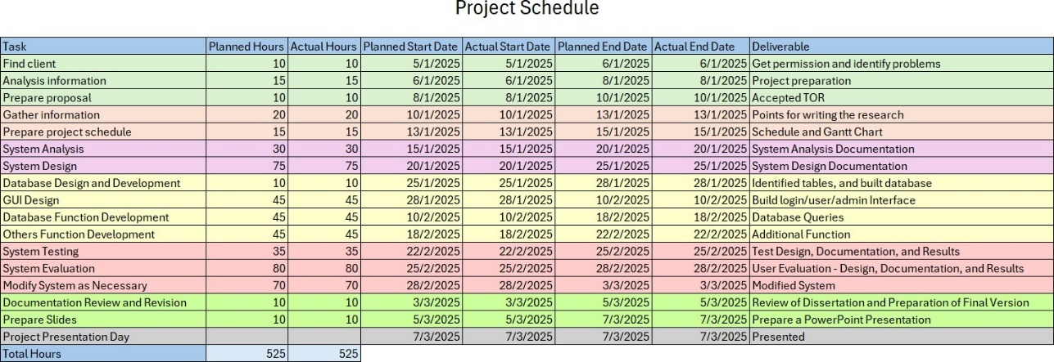

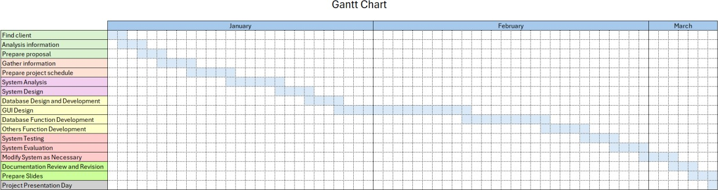

## Chapter 3.0 System Analysis and Design

#### Requirement Gathering

The development of this system required a structured approach to gathering requirements, ensuring that all functionalities align with the needs of Windy Autos. The requirements were collected primarily through discussions with Mr. Ng, who provided insight into his current business processes, pain points, and expectations for the new system.

Mr. Ng emphasized that the system should be easy to use, as he has minimal experience with digital tools. He wanted the ability to manage car inventory, customer records, and transaction history while minimizing the time spent on administrative work. Additionally, since the business operates solely under his management, user authentication and access control were implemented to allow potential expansion without compromising security.

To better illustrate how the system processes data, an Input-Process-Output (IPO) table was created.

#### Input-Process-Output (IPO) Table

|  |  |  |
| --- | --- | --- |
| Input | Process | Output |
| Car details (make, model, year, price) | Store and manage car information | View, search, update, delete car records |
| Customer details (name, contact, purchase history) | Store and manage customer data | View, search, update, delete customer records |
| Transaction details (date, payment method, amount) | Generate invoices and receipts, calculate totals | Print invoice, store transaction history |
| User details (username, password) | Authenticate user access | Grant or deny access based on user role |
| Accounting details | Generate business performance reports | View and print customized reports |

The requirement gathering phase ensures that all core functionalities are aligned with the business objectives of Windy Autos. The subsequent stages of system analysis and design focus on structuring these requirements into a functional system.

#### Flow Chart

Login

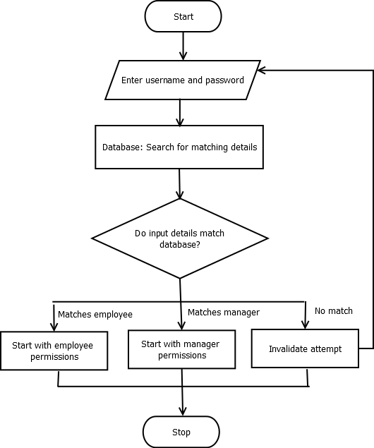

Transaction

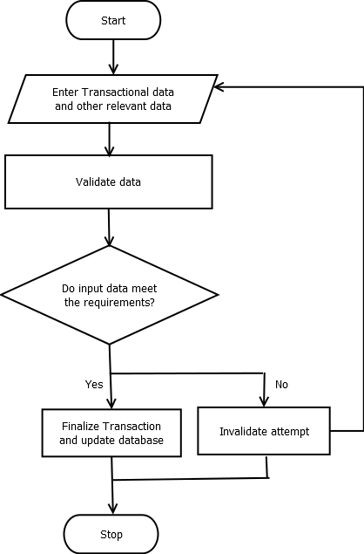

#### Context Diagram

* 1. **Data Flow Diagram**

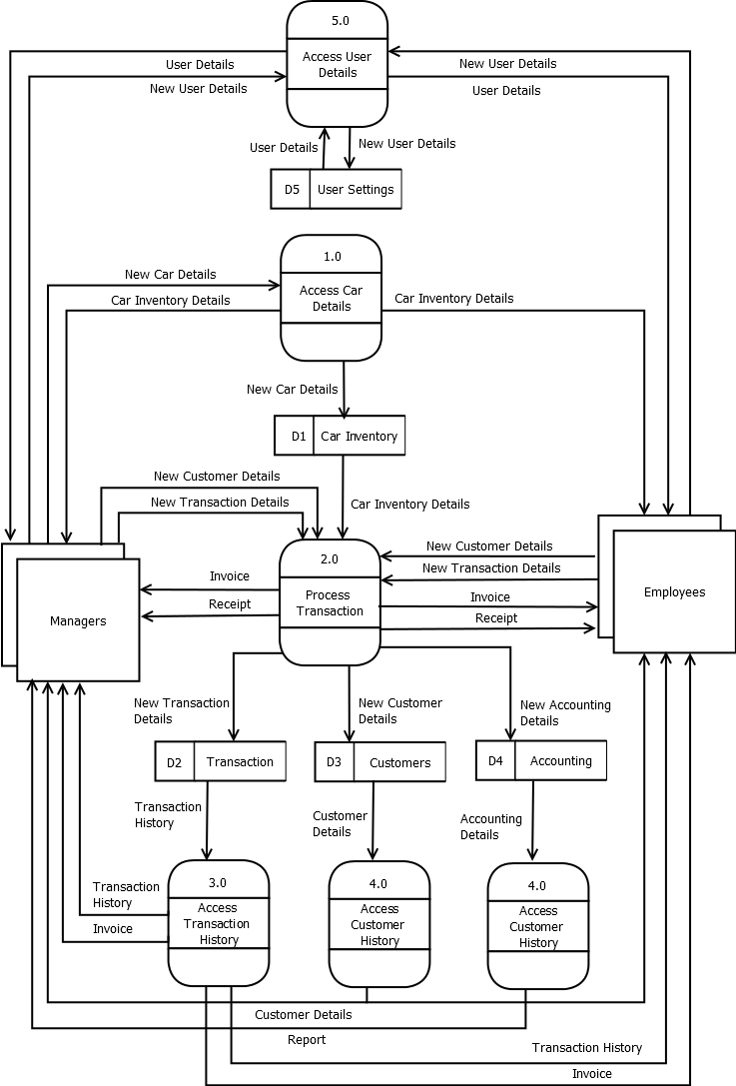

#### Data Dictionary

The main tables are Cars, Customers, Transactions, Users, and Accounting. Cars

|  |  |
| --- | --- |
| **Column Name** | **Data Type** |
| Car_ID (PK) | nvarchar(50) |
| Make | nvarchar(MAX) |
| Model | nvarchar(MAX) |
| Year | int |
| VIN | nvarchar(MAX) |
| Mileage | int |
| Bought_Price | decimal(18,2) |
| Asking_Price | decimal(18,2) |
| Date_Added | datetime |
| Car_Image | varchar(MAX) |
| Sale_Status | nvarchar(50) |
| Customer_ID | nvarchar(50) |

Customers

|  |  |
| --- | --- |
| **Column Name** | **Data Type** |
| Customer_ID (PK) | nvarchar(50) |
| Last_Name | nvarchar(MAX) |
| First_Name | nvarchar(MAX) |
| IC_No | nvarchar(50) |
| License_No | nvarchar(50) |
| Phone | nvarchar(50) |
| Email | nvarchar(MAX) |
| Address_Line1 | nvarchar(MAX) |
| Address_Line2 | nvarchar(MAX) |
| Address_Line3 | nvarchar(MAX) |
| Address_Line4 | nvarchar(MAX) |
| Full_Address | nvarchar(MAX) |
| Date_Added | datetime |

Transactions

|  |  |
| --- | --- |
| **Column Name** | **Data Type** |
| Transaction_ID (PK) | nvarchar(50) |
| Car_ID | nvarchar(50) |
| Customer_ID | nvarchar(50) |
| User_ID | nvarchar(50) |
| Base_Price | decimal(18,2) |
| Sales_Tax | decimal(18,2) |
| Registration_Fee | decimal(18,2) |
| Documentation_Fee | decimal(18,2) |
| Other_Fees | decimal(18,2) |
| Grand_Total | decimal(18,2) |
| Payment_Method | nvarchar(50) |
| Date_Added | datetime |

Users

|  |  |
| --- | --- |
| **Column Name** | **Data Type** |
| User_ID (PK) | nvarchar(50) |
| Username | nvarchar(50) |
| Password | nvarchar(50) |
| Position | nvarchar(50) |
| Date_Created | datetime |

Accounting

|  |  |
| --- | --- |
| **Column Name** | **Data Type** |
| Accounting_ID (PK) | nvarchar(50) |
| Revenue | decimal(18,2) |
| COGS | decimal(18,2) |
| Gross_Profit | decimal(18,2) |
| Net_Profit | decimal(18,2) |
| Date_Added | datetime |

#### Database Design

All the tables have one primary key, no foreign key and are therefore independent of each other.

#### Interface Design

Login window - Manager & Employee

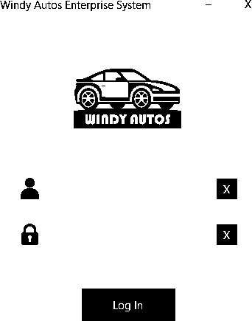

Dashboard window - Manager

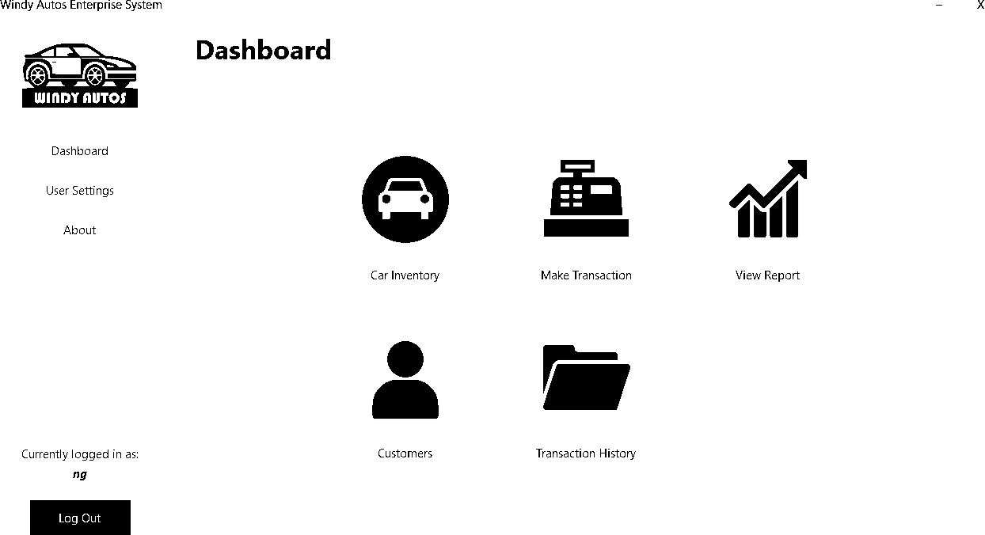

Dashboard window – Employee

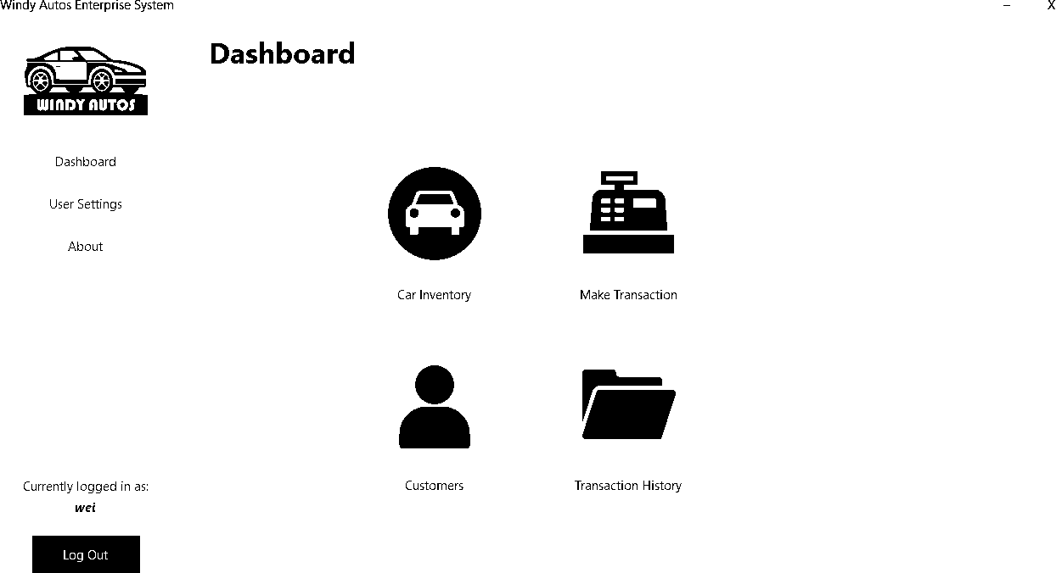

Car Inventory - Manager

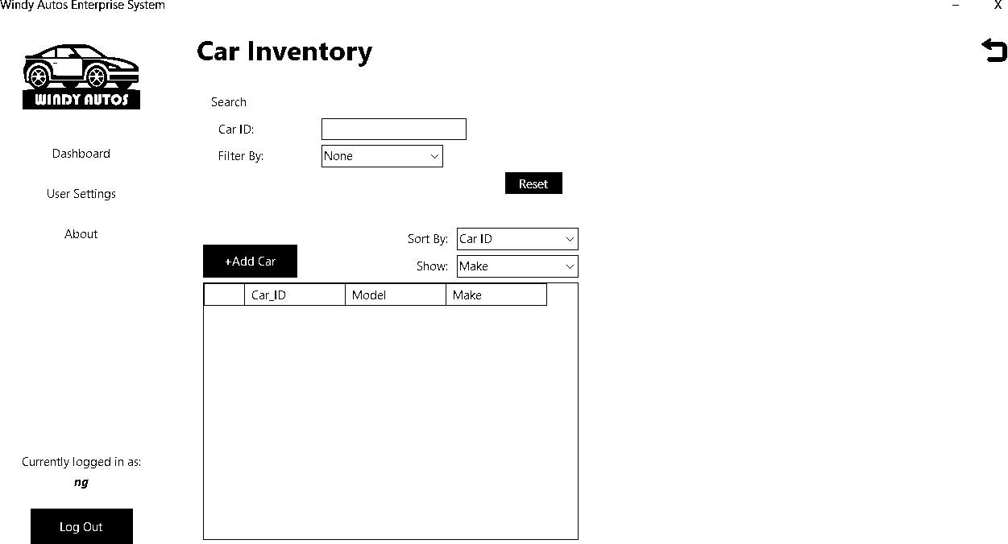

Car Inventory – Manager - Add Car

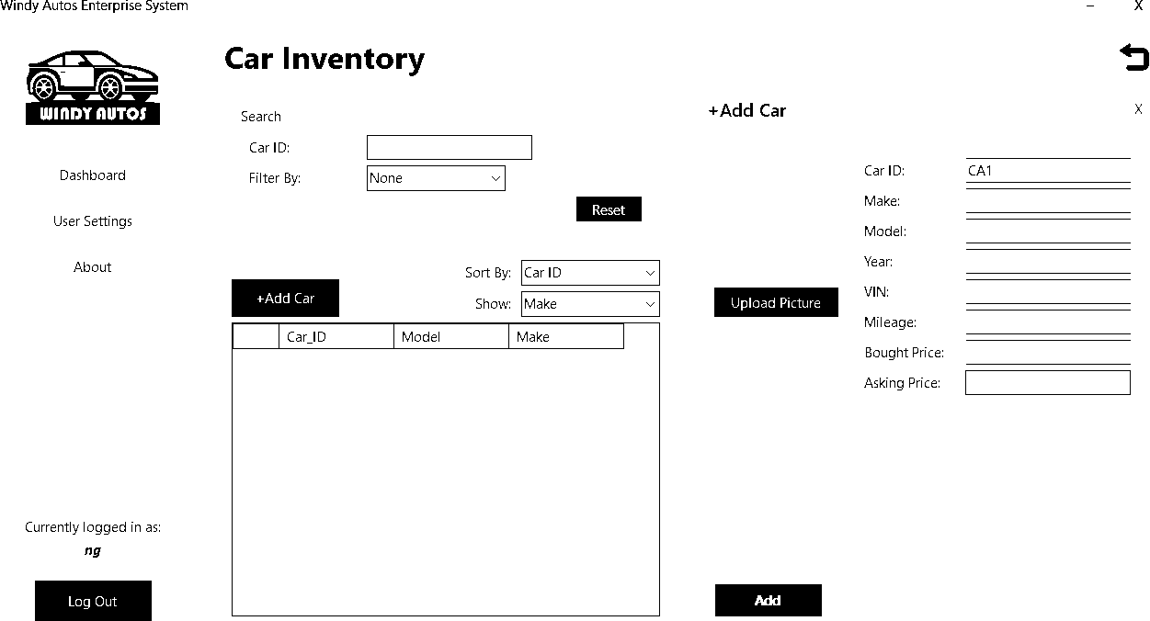

Car Inventory - Manager – Update Car

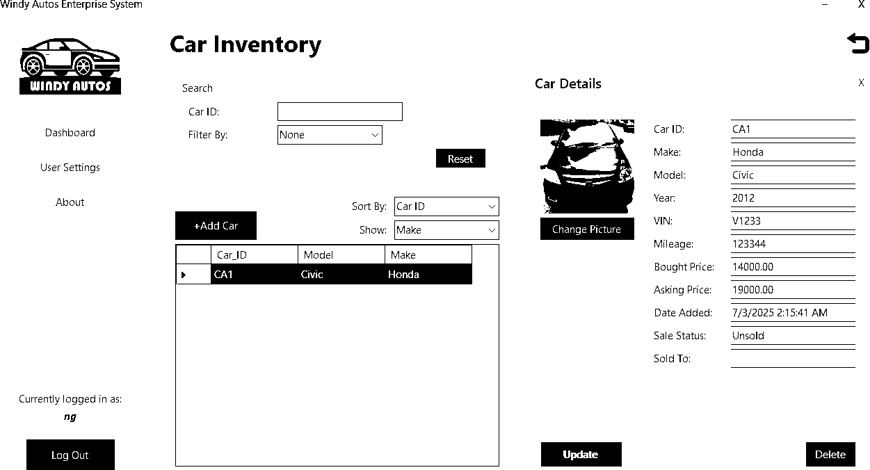

Car Inventory - Employee

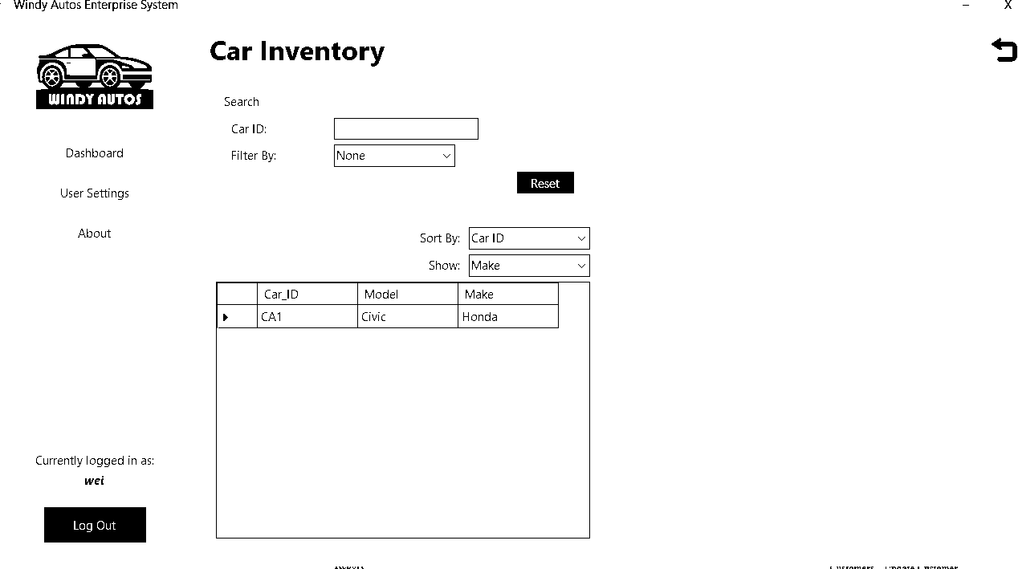

Car Inventory – Employee – Update Car

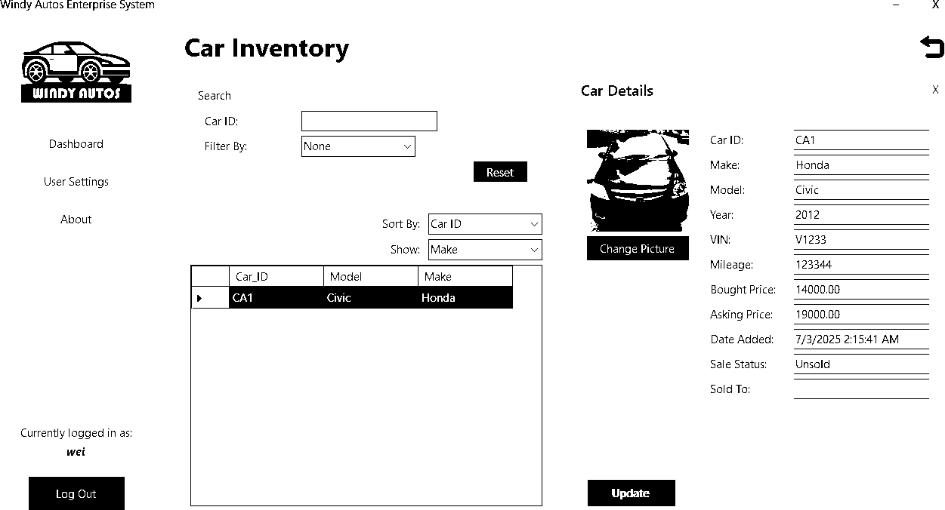

User Transaction - Manager & Employee

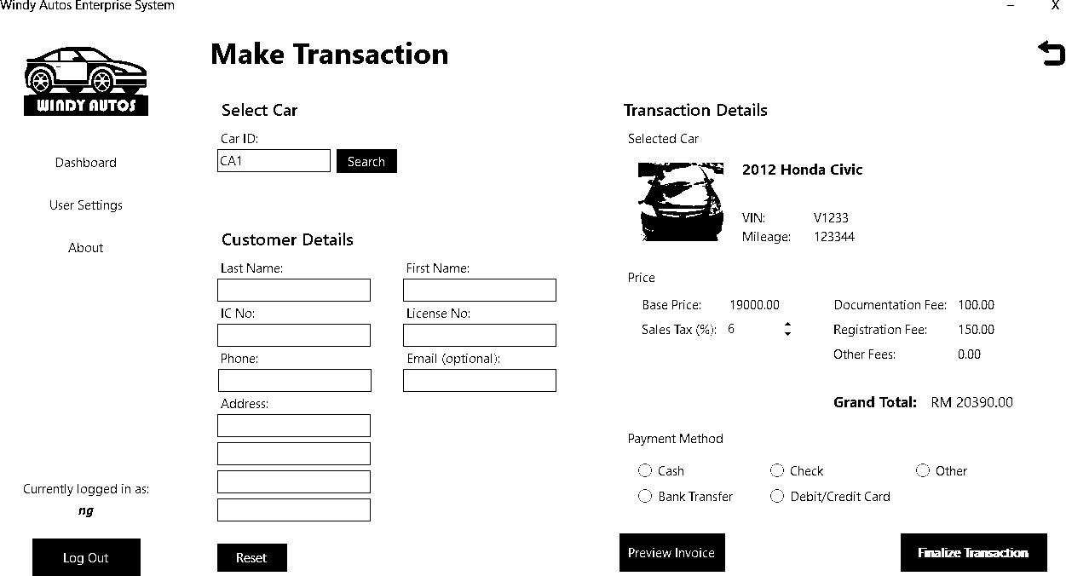

Report- Manager

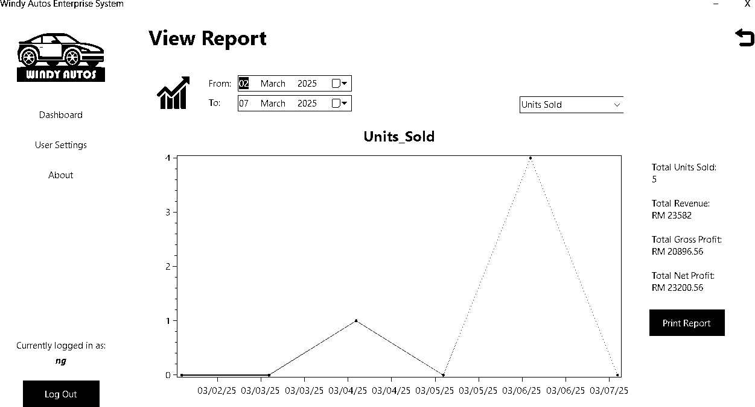

Customers - Manager & Employee

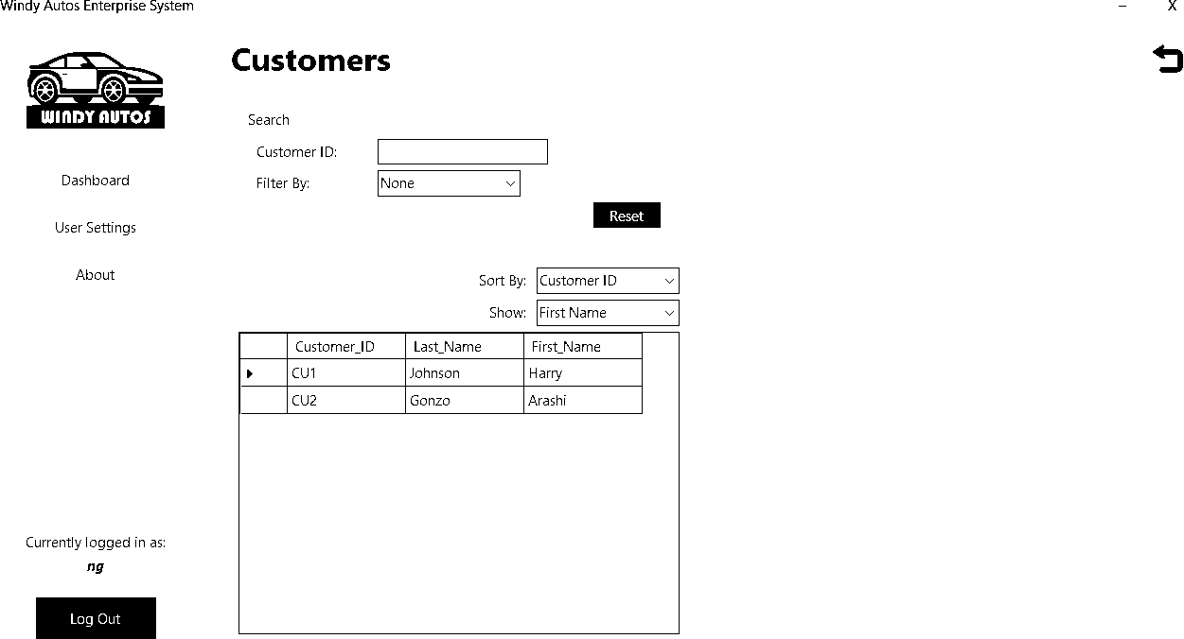

Customers – Manager - Update Customer

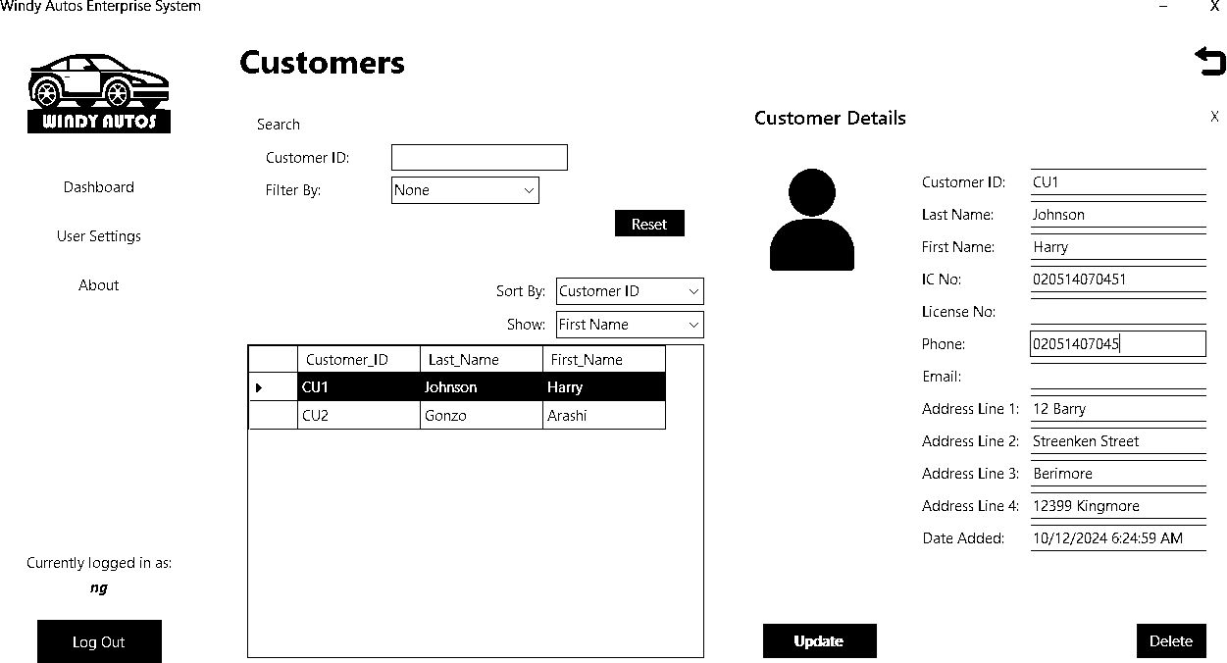

Customers – Employee – Update Customer

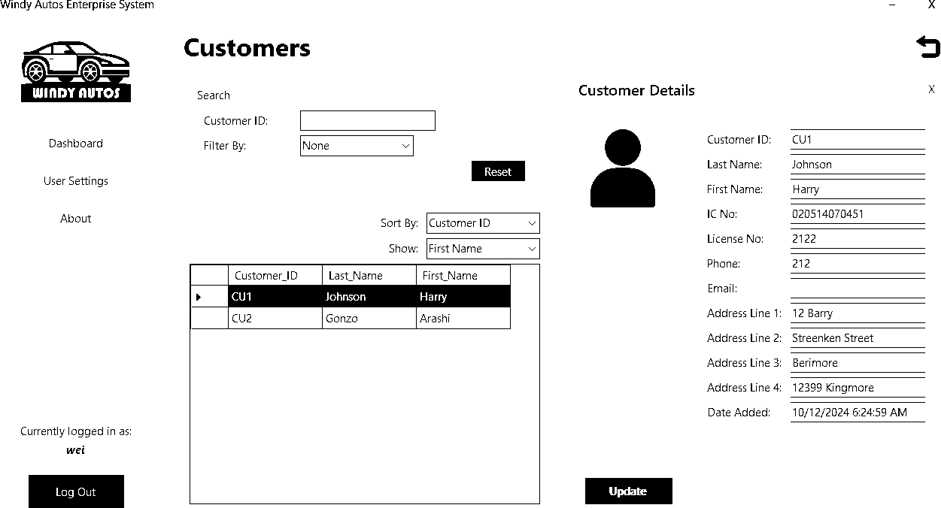

Transaction History – Manger & Employee

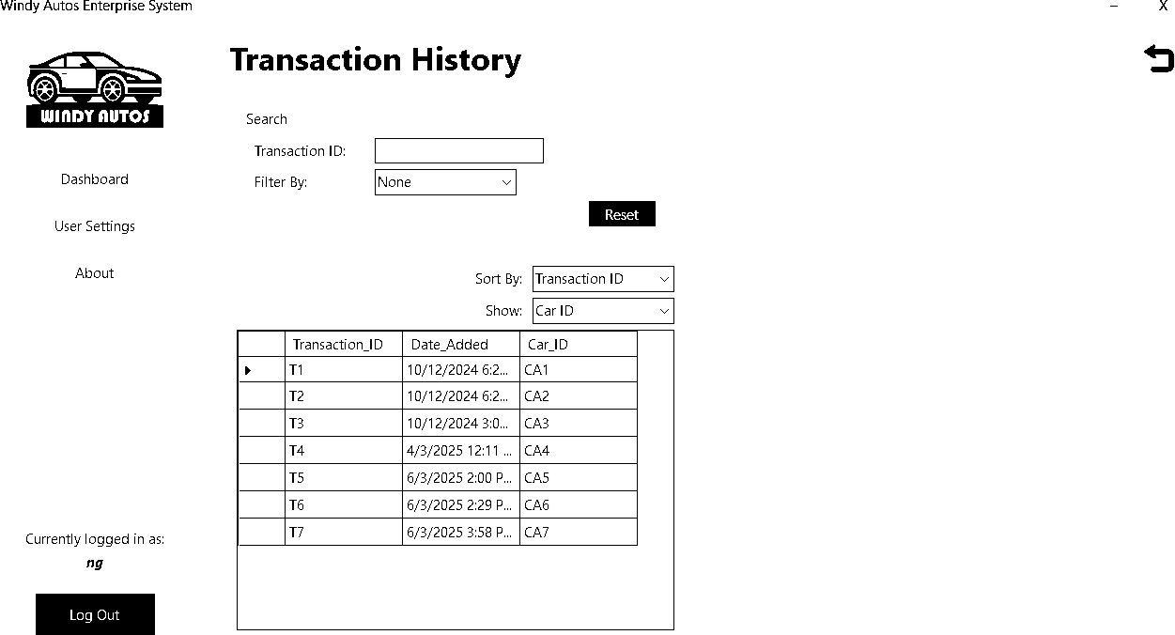

Transaction History - Manager – Print

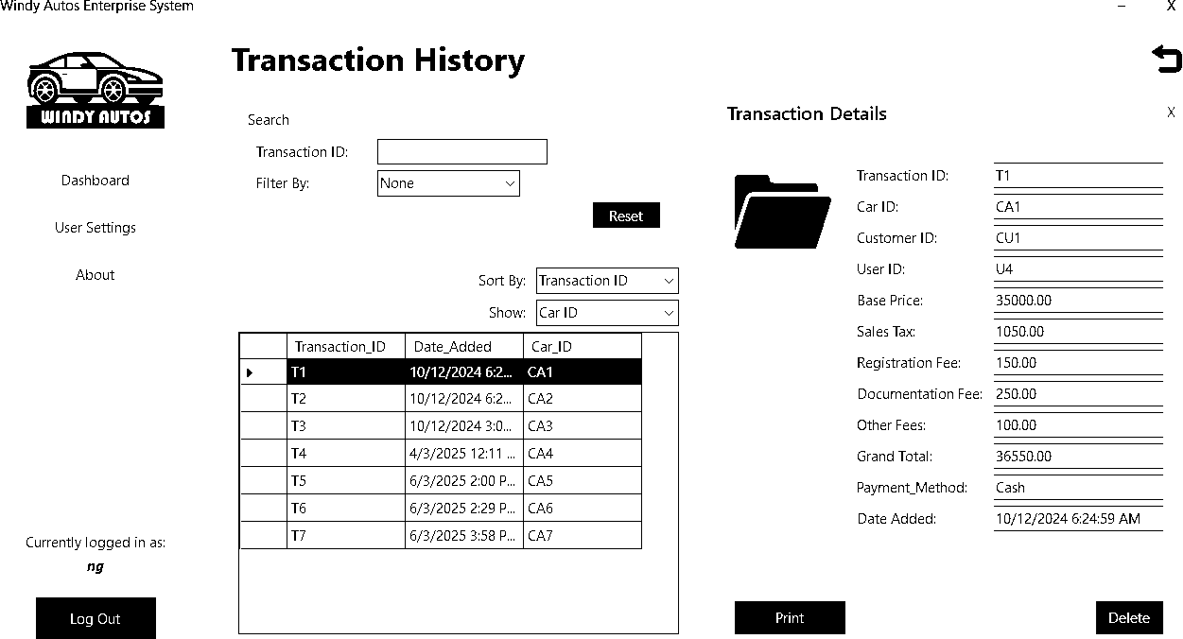

Transaction History – Employee – Print

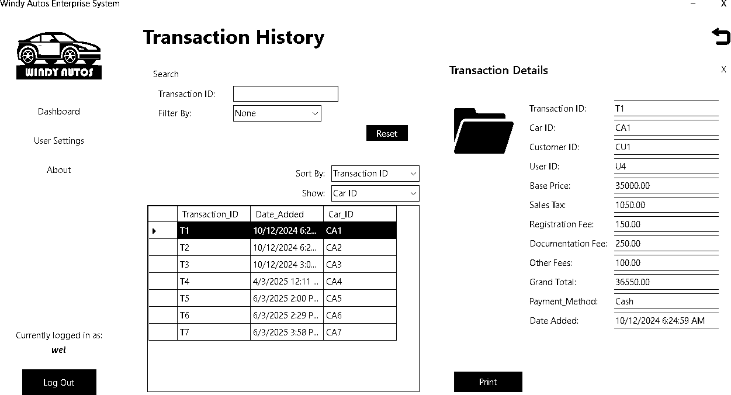

User Settings - Manager

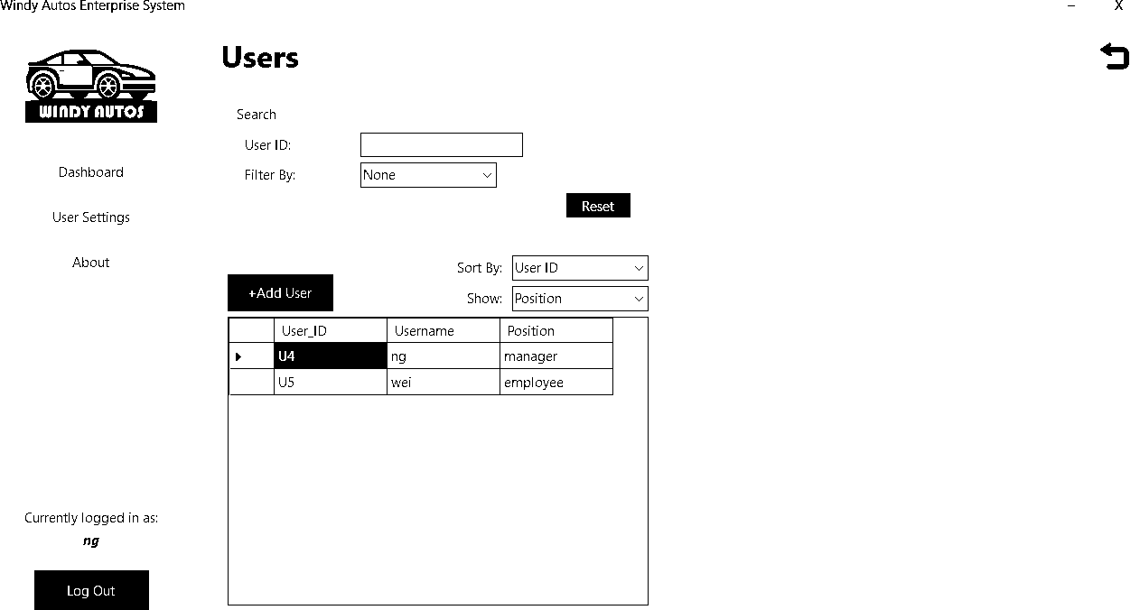

User Settings – Manger - Add User

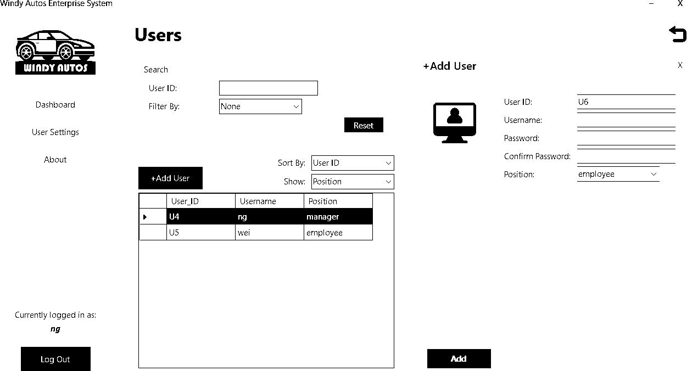

User Settings – Manager - Update User

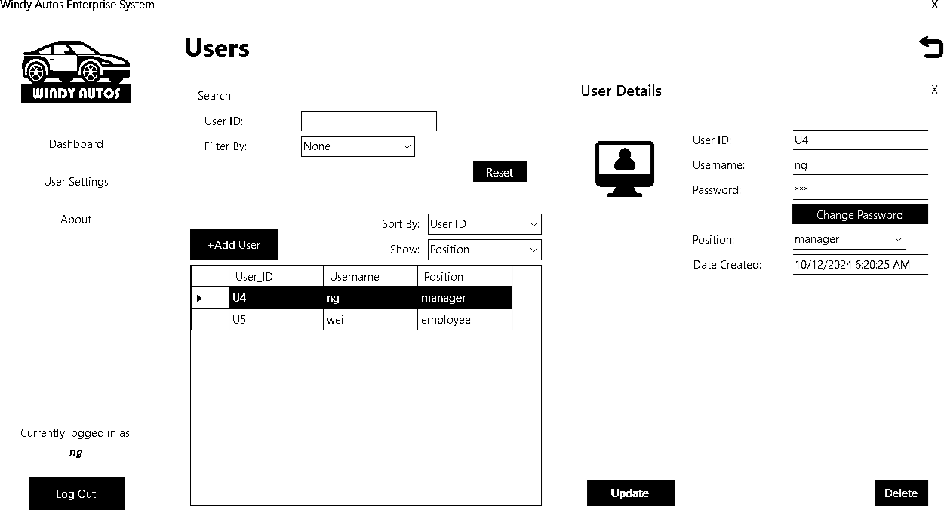

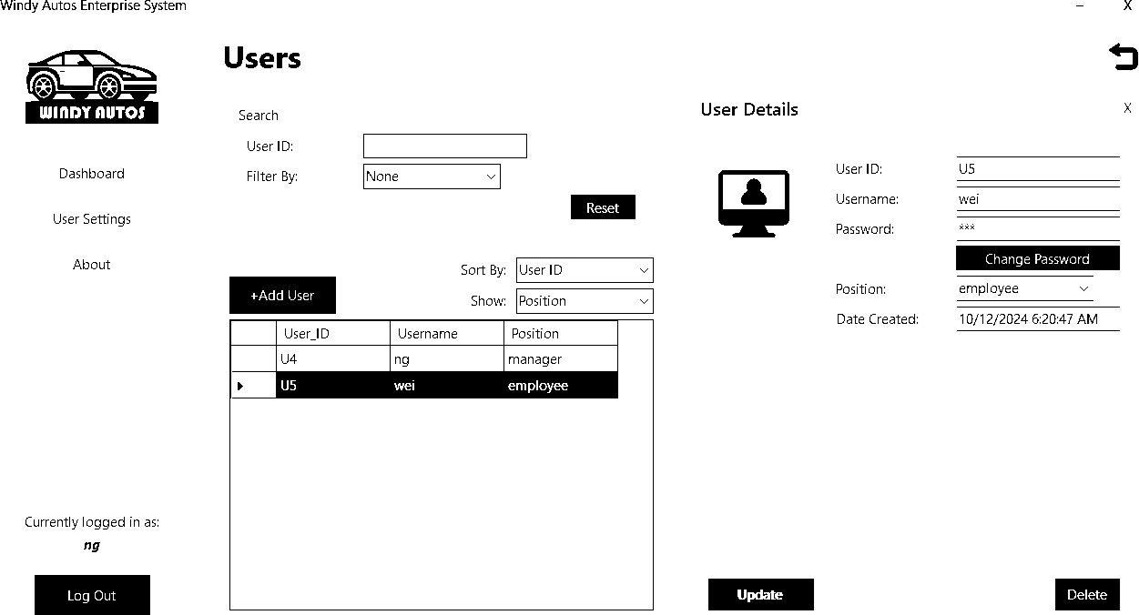

User Settings – Employee – Update User

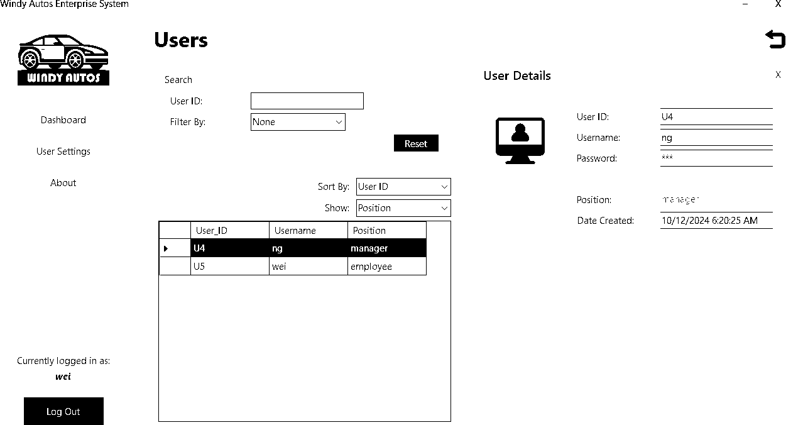

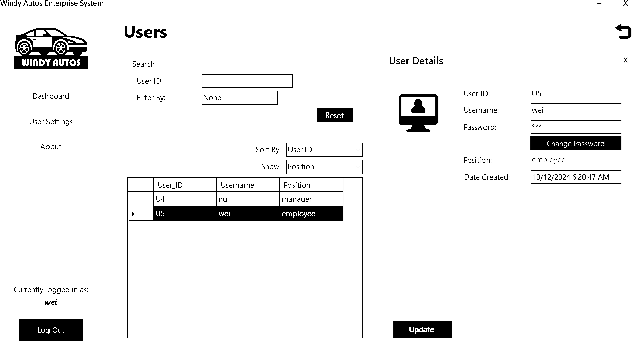

User Settings – Manager & Employee - Change Password

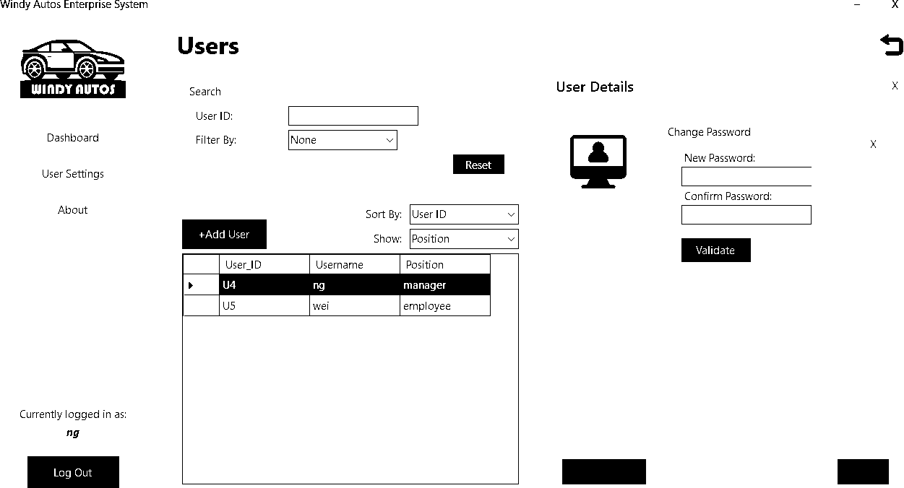

## Chapter 4.0 System Development

#### System Use Case

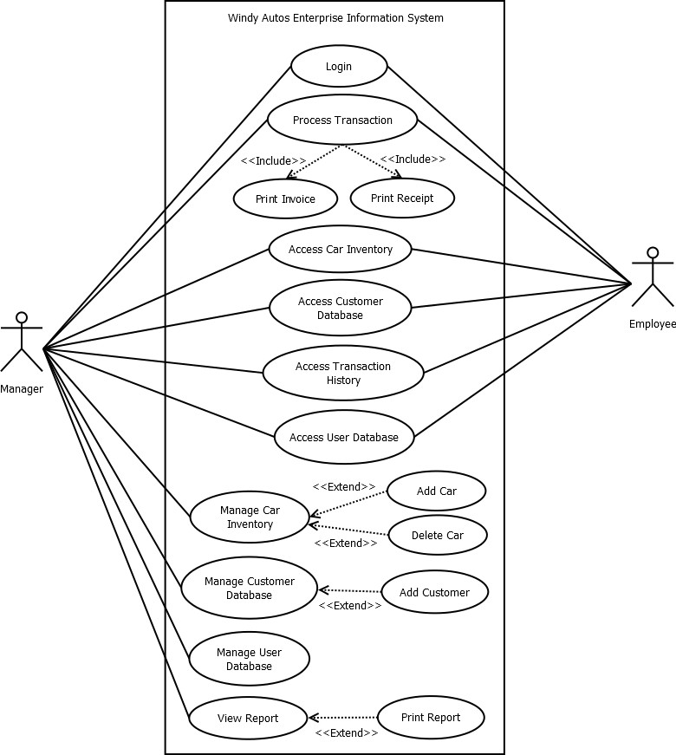

* 1. **Database**

The database is created using Microsoft SQL. Microsoft SQL is chosen because of its ease of integration with Microsoft Visual Studio and C#. The main tables are Cars, Customers, Transactions, Users, and Accounting. Graph is a container table for the report graph function.

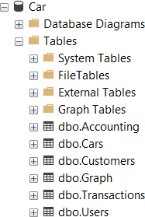

Cars

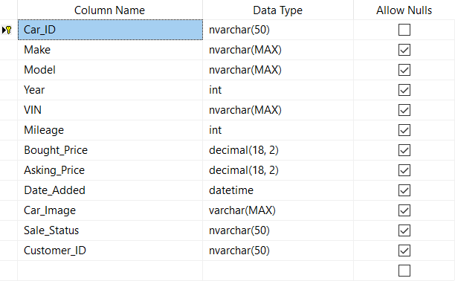

Customers

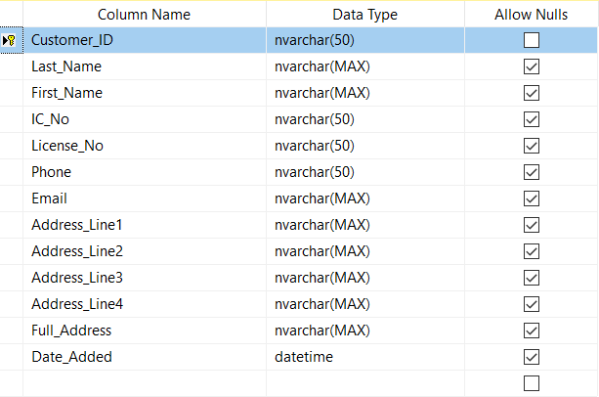

Transactions

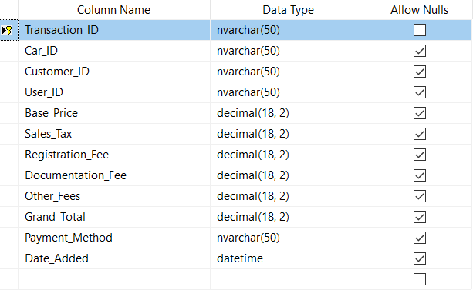

Users

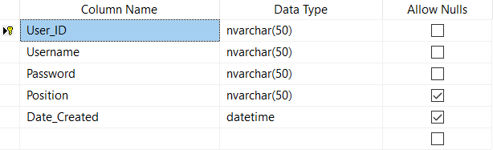

Accounting

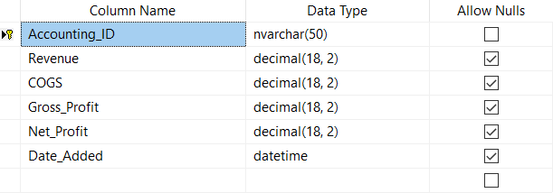

#### Validation and Verification

User Login

The login process has a simple validation process where it checks if the given username exists in the user database and then checks if the password matches the one given.

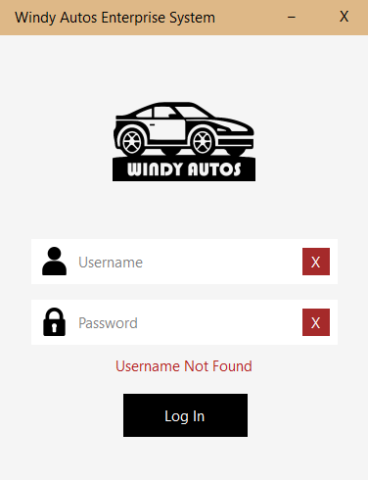

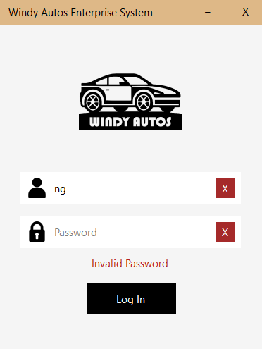

User Transaction

The transaction process works by selecting a car, inputting customer data, and the relevant transactional details like payment method. If any of the required fields are empty or insufficient the program will not finalize the transaction. The program will first validate the Car ID by checking if the car exists in the car inventory and if it is unsold. In customer details, only the email address field is optional; there fields for IC number, license number, and phone number are length and numeric sensitive, meaning the characters are limited a certain length and only numeric characters are allowed. The same numeric sensitivity applies to the price fields.

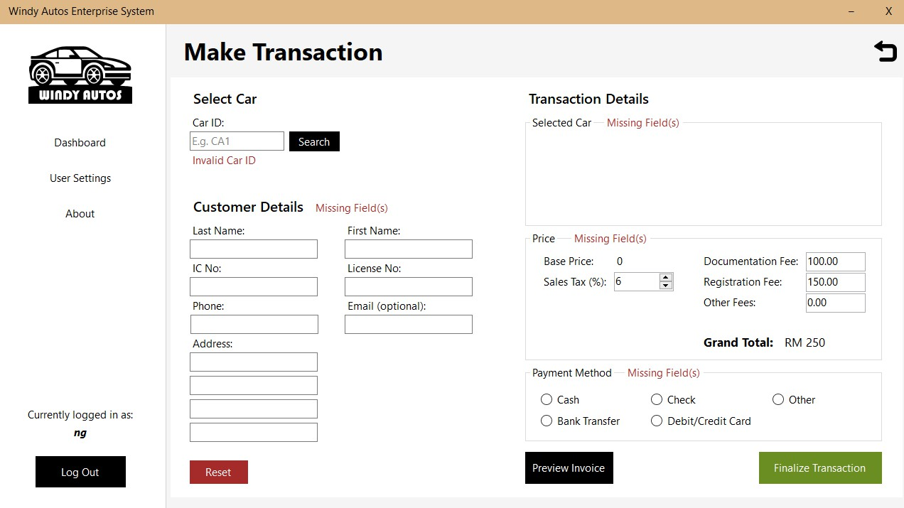

User Settings

If there is only one manager account, it is unable to delete itself or change its own status to employee.

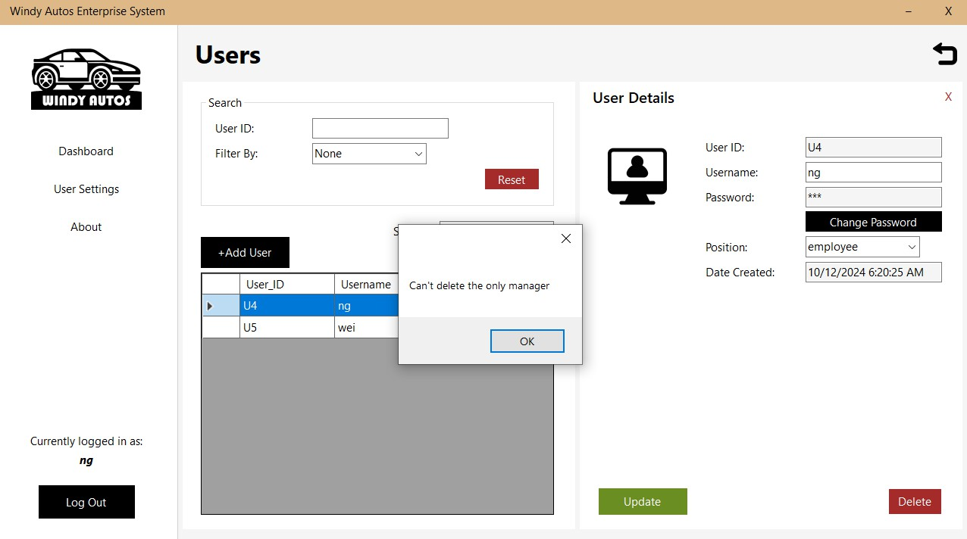

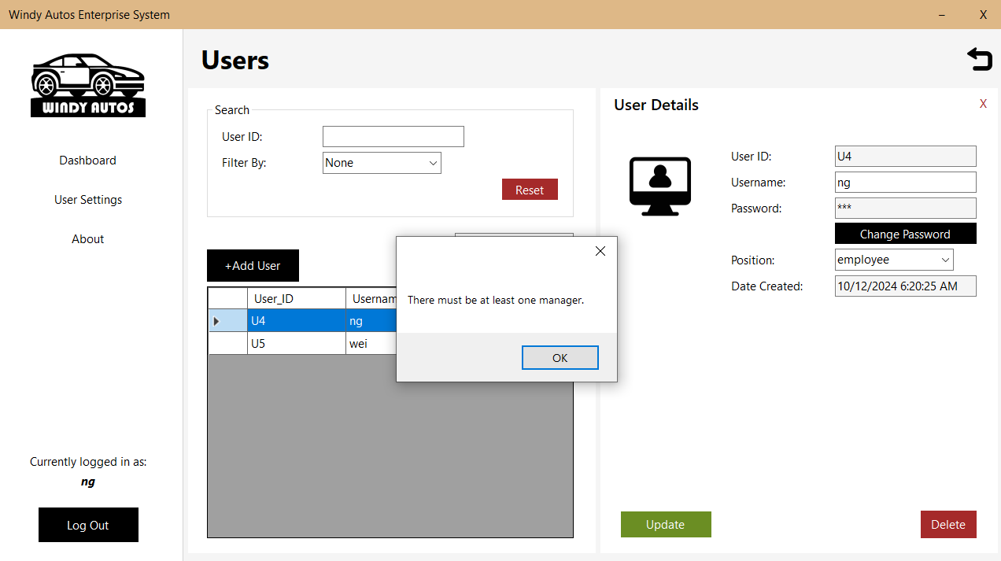

#### Program Code

|  |  |
| --- | --- |
| File name | Function |
| Form1.cs | The login window, the user’s first screen; they may return here after logging out. |
| Form2.cs | The main window, contains a side panel menu and a window for the UserControls. |
| UserControl1.cs | The dashboard, contains the options for the various other UserControls. |
| UserControl2.cs | Car Inventory panel, responsible for viewing and editing the Cars table. |
| UserControl3.cs | User Transaction panel, responsible for marking a car inventory as sold, and adding a new entry to the Customers, Transactions,  and Accounting tables, and to print an invoice and receipt. |
| UserControl4.cs | Customers panel, responsible for viewing and editing the Customers table. |

|  |  |
| --- | --- |
| UserControl5.cs | Transactions panel, responsible for viewing the Transactions table, and to print an invoice. |
| UserControl6.cs | User Settings panel, responsible for viewing and editing the  Users table. Allows manager accounts to manage other users and for employee accounts to modify personal account details. |
| UserControl7.cs | Report panel, pulls data from Accounting table to be displayed as a graph depending on the start and end dates given, and to  print a summary report. |
| Class1.cs | Contains the PDF format for the printable items. |

* 1. **User Interface**

Login window - Manager & Employee

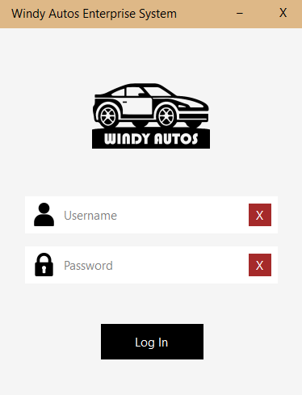

Dashboard window - Manager

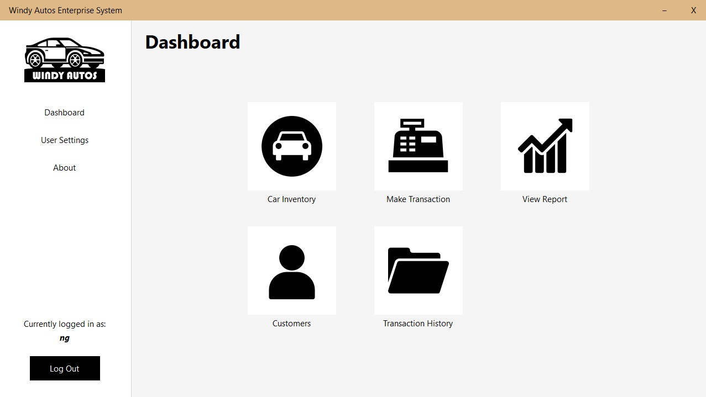

Dashboard window – Employee

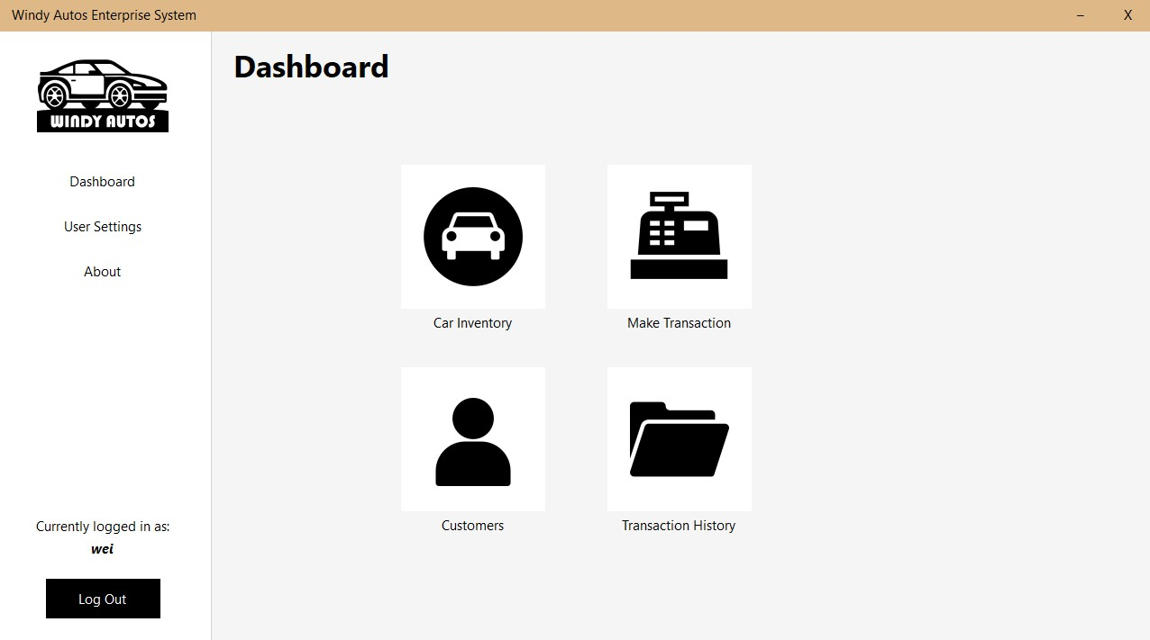

Car Inventory - Manager

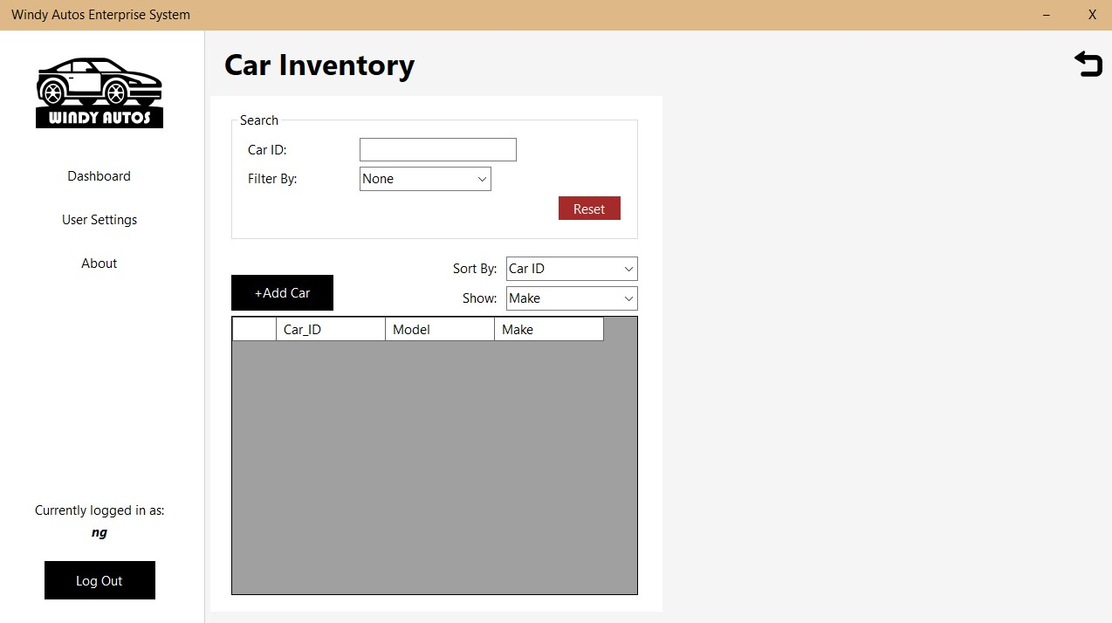

Car Inventory – Manager - Add Car

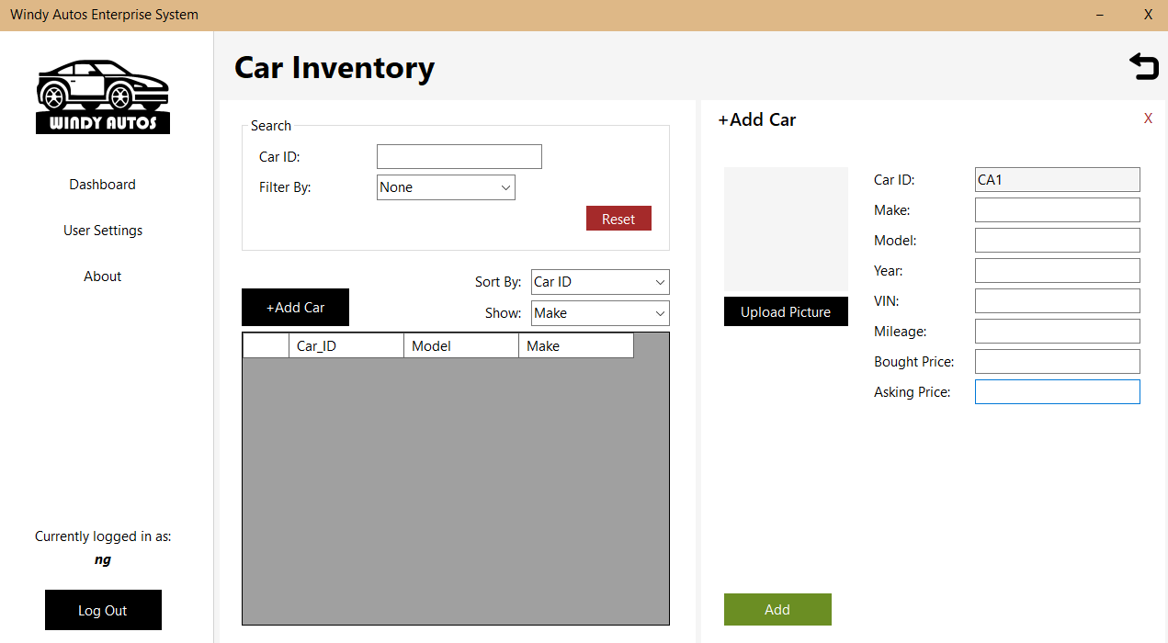

Car Inventory - Manager – Update Car

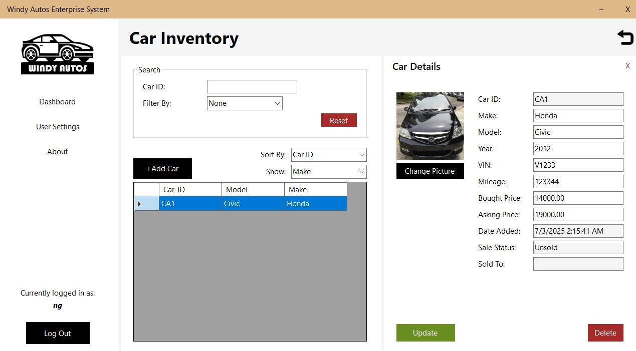

Car Inventory - Employee

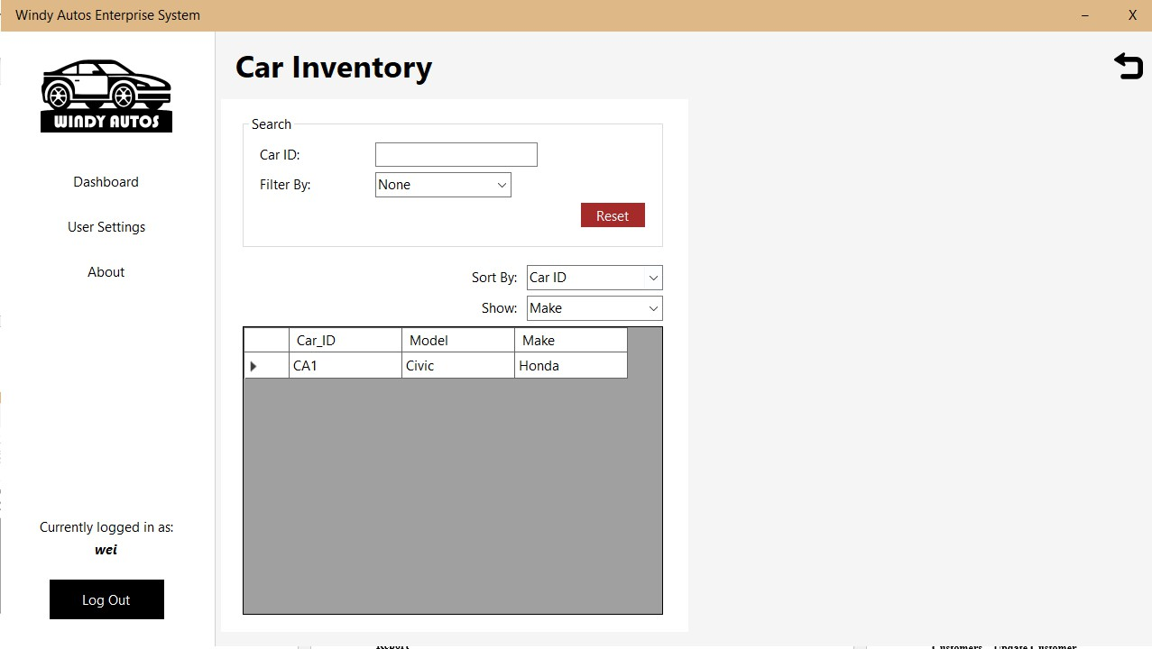

Car Inventory – Employee – Update Car

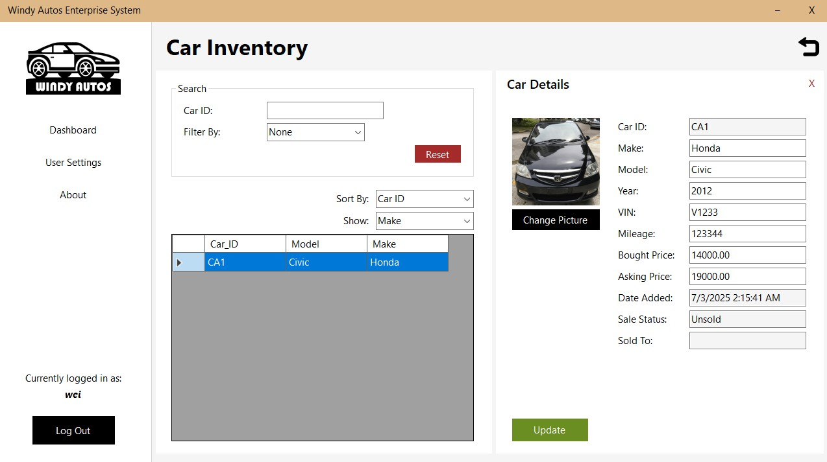

User Transaction - Manager & Employee

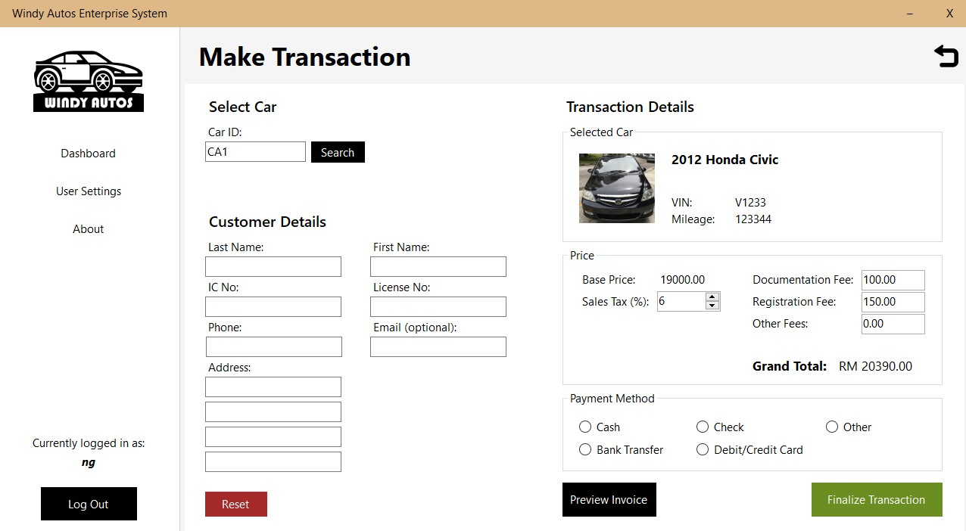

Report- Manager

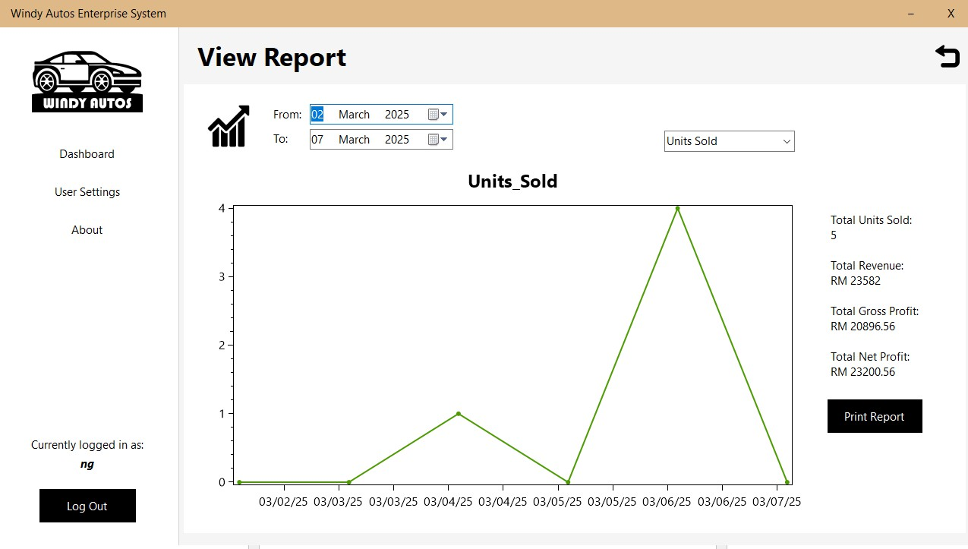

Customers - Manager & Employee

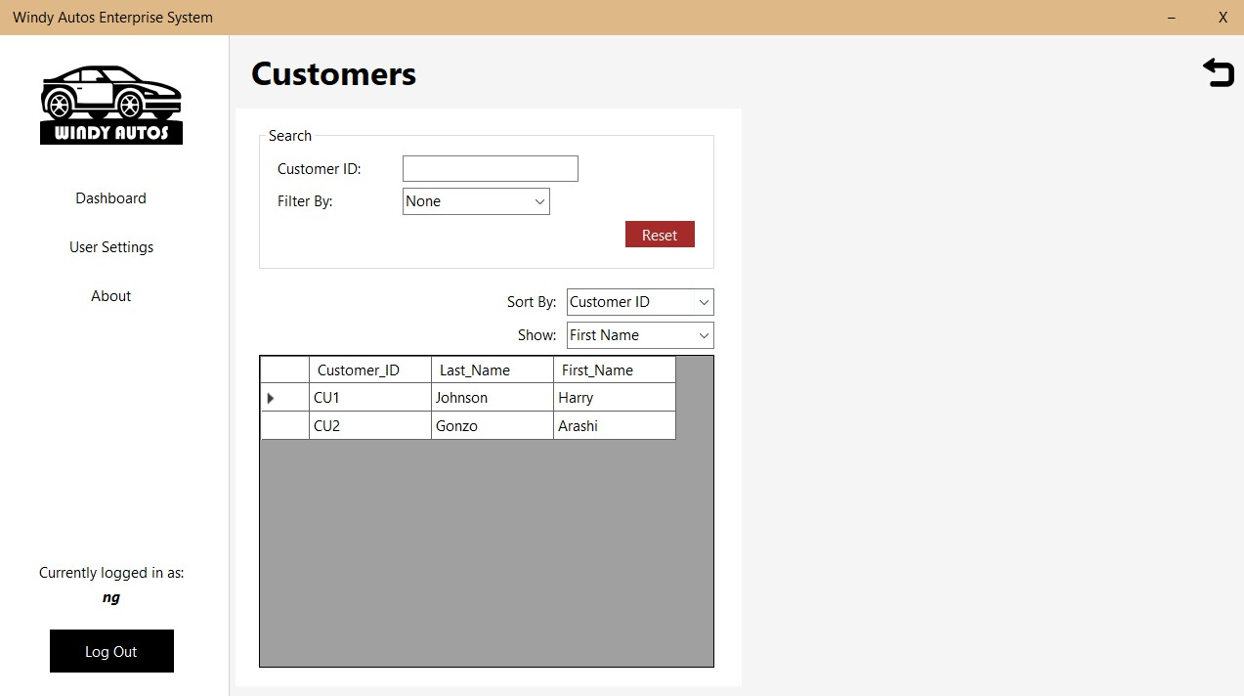

Customers – Manager - Update Customer

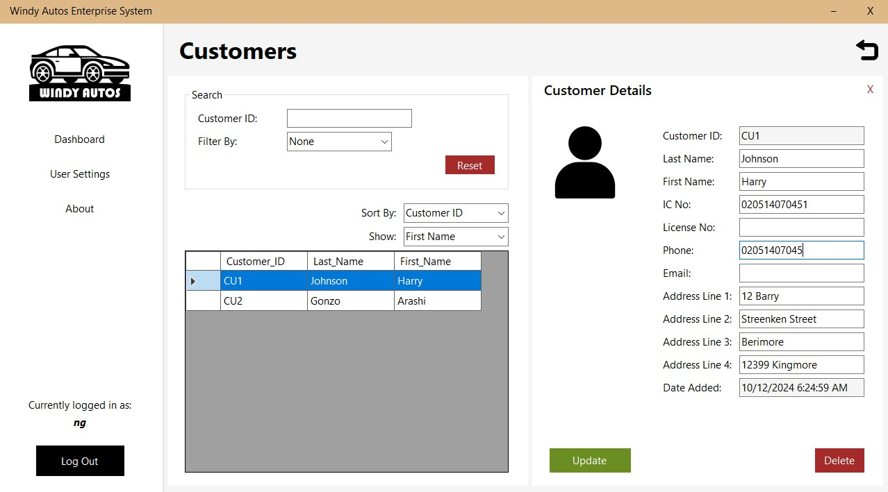

Customers – Employee – Update Customer

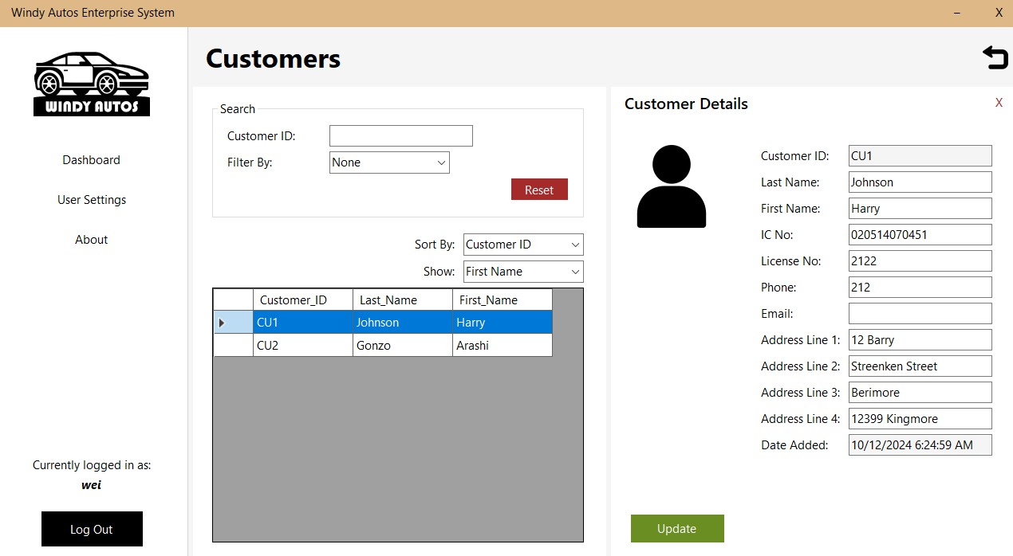

Transaction History – Manger & Employee

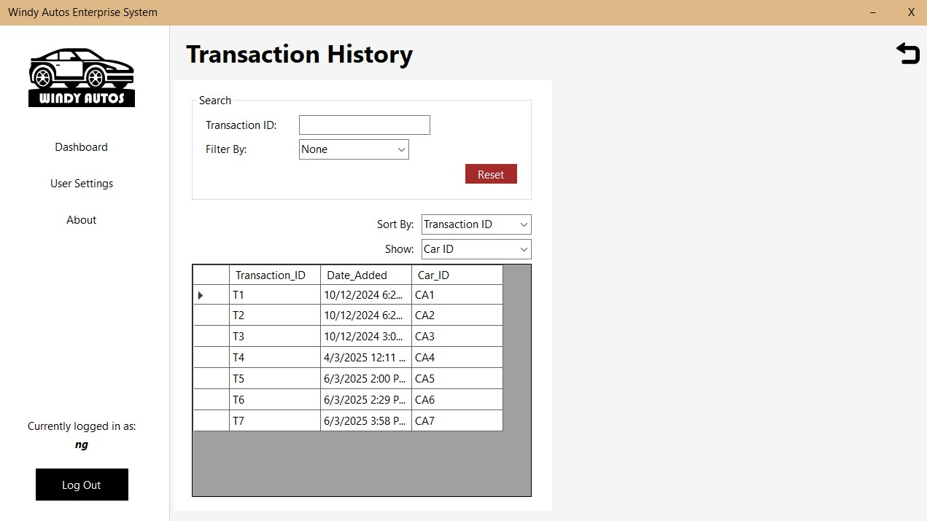

Transaction History - Manager – Print

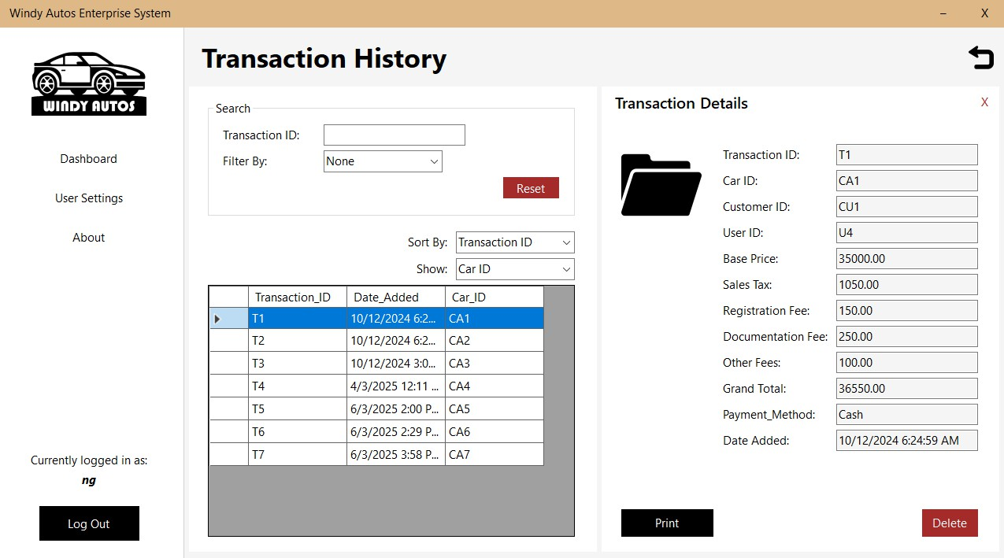

Transaction History – Employee – Print

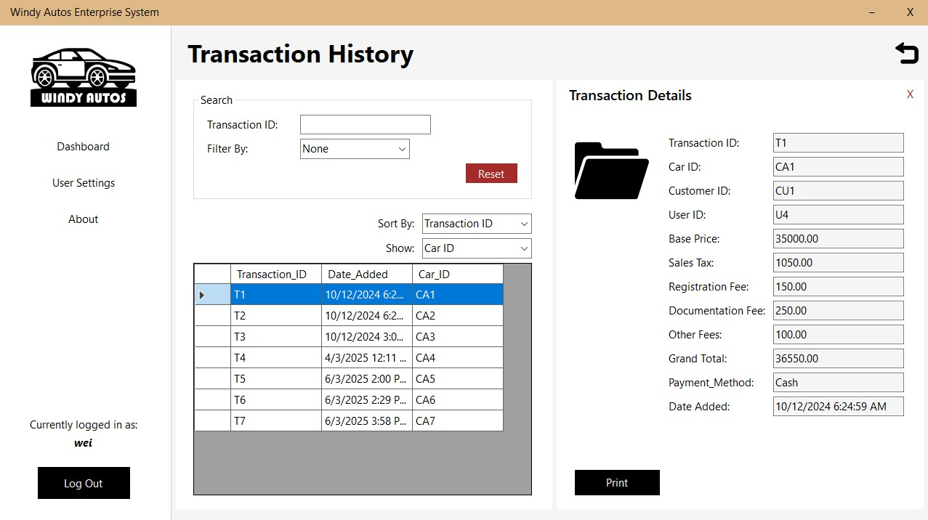

User Settings - Manager

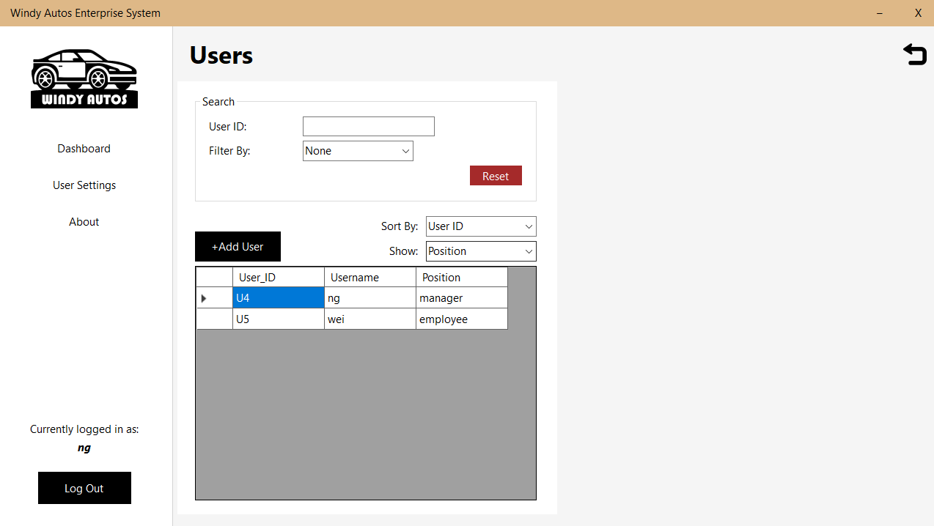

User Settings – Manger - Add User

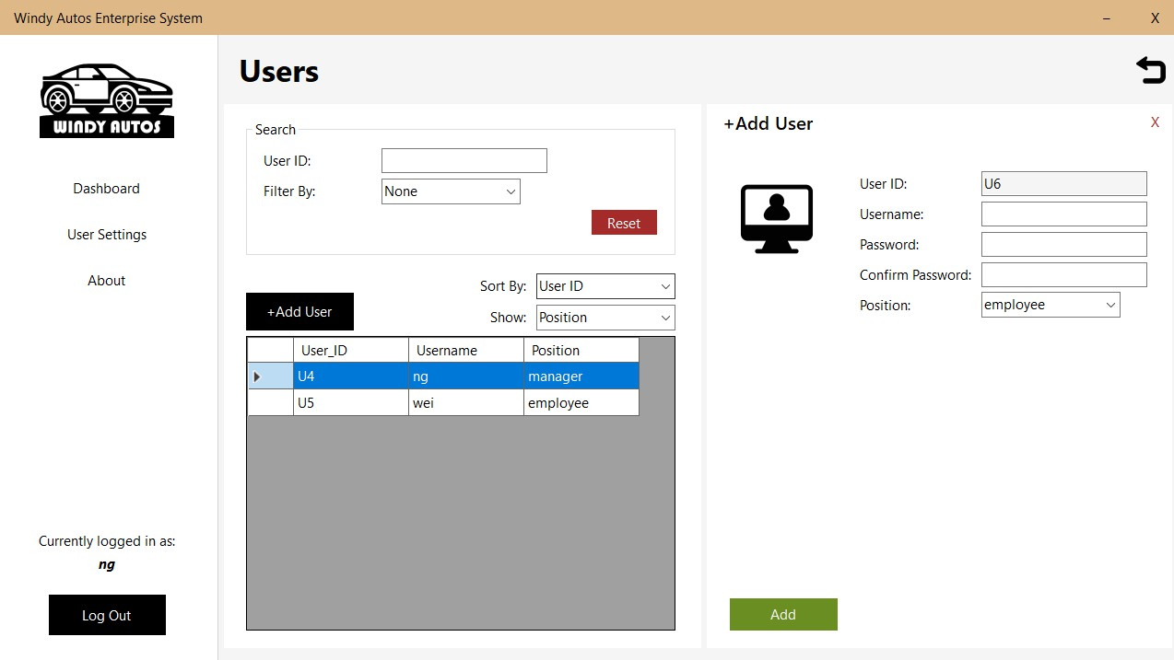

User Settings – Manager - Update User

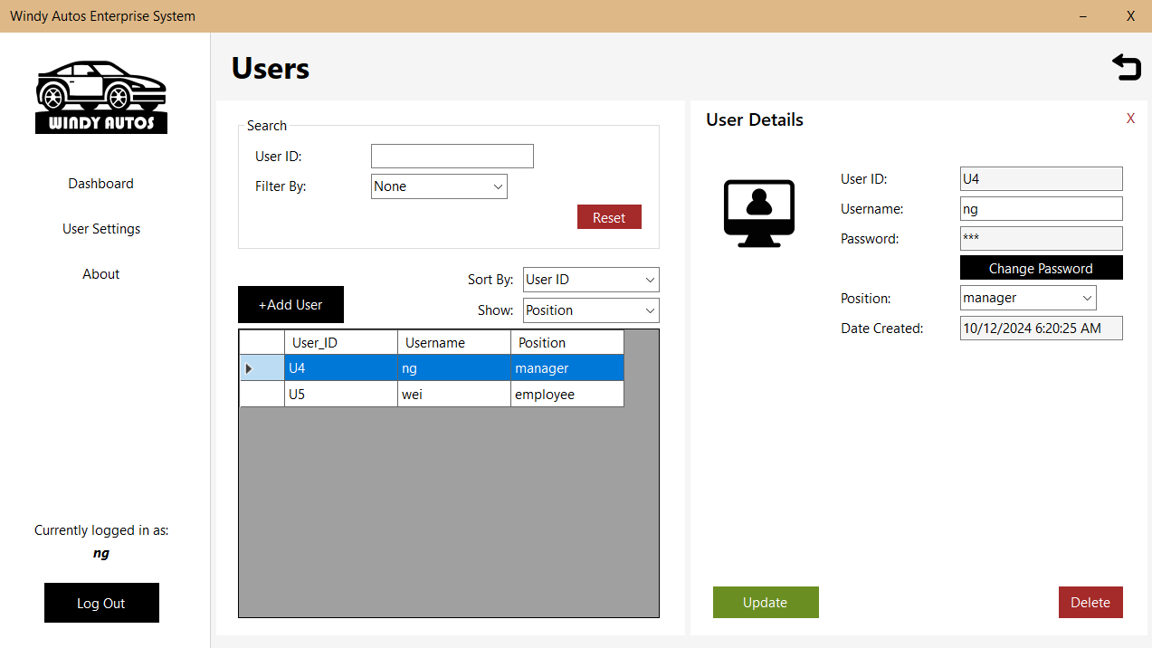

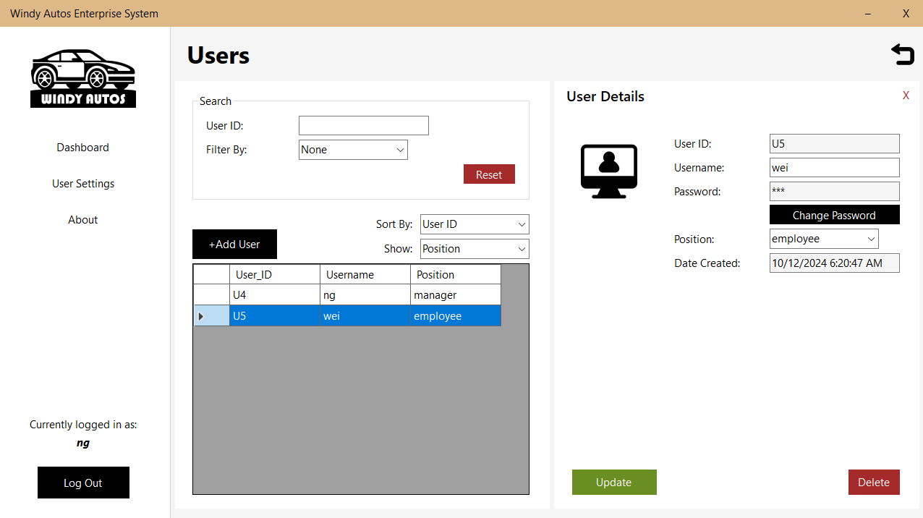

User Settings – Employee – Update User

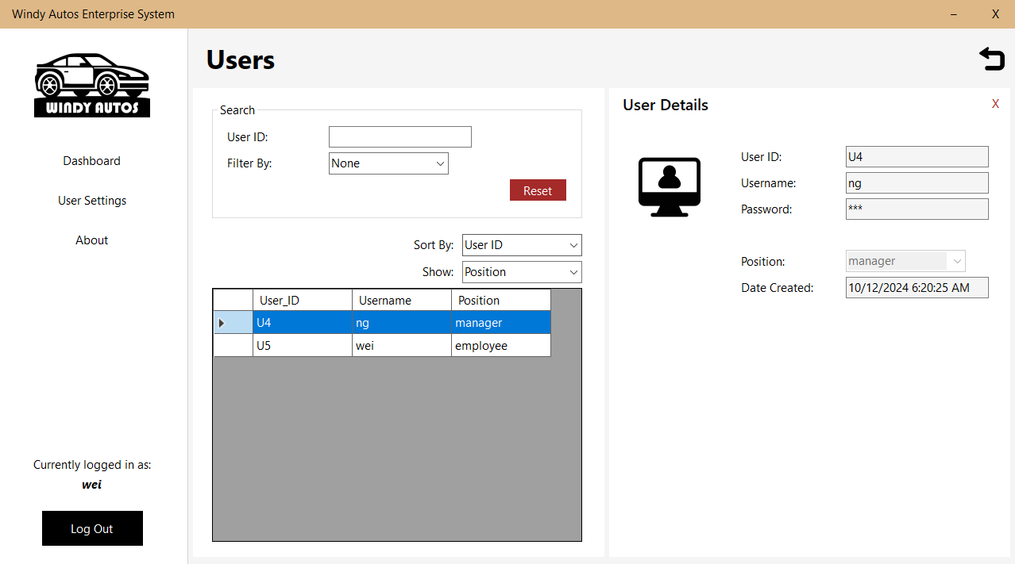

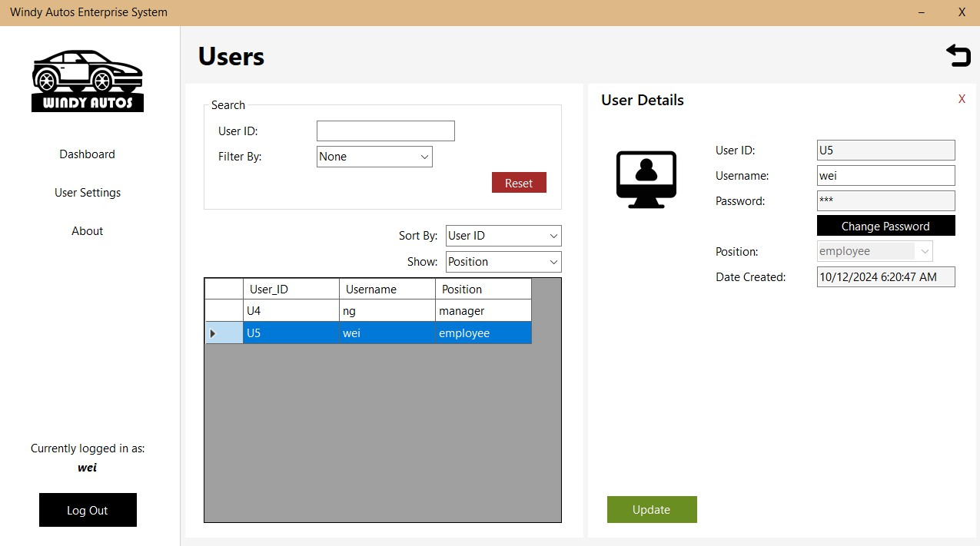

User Settings – Manager & Employee - Change Password

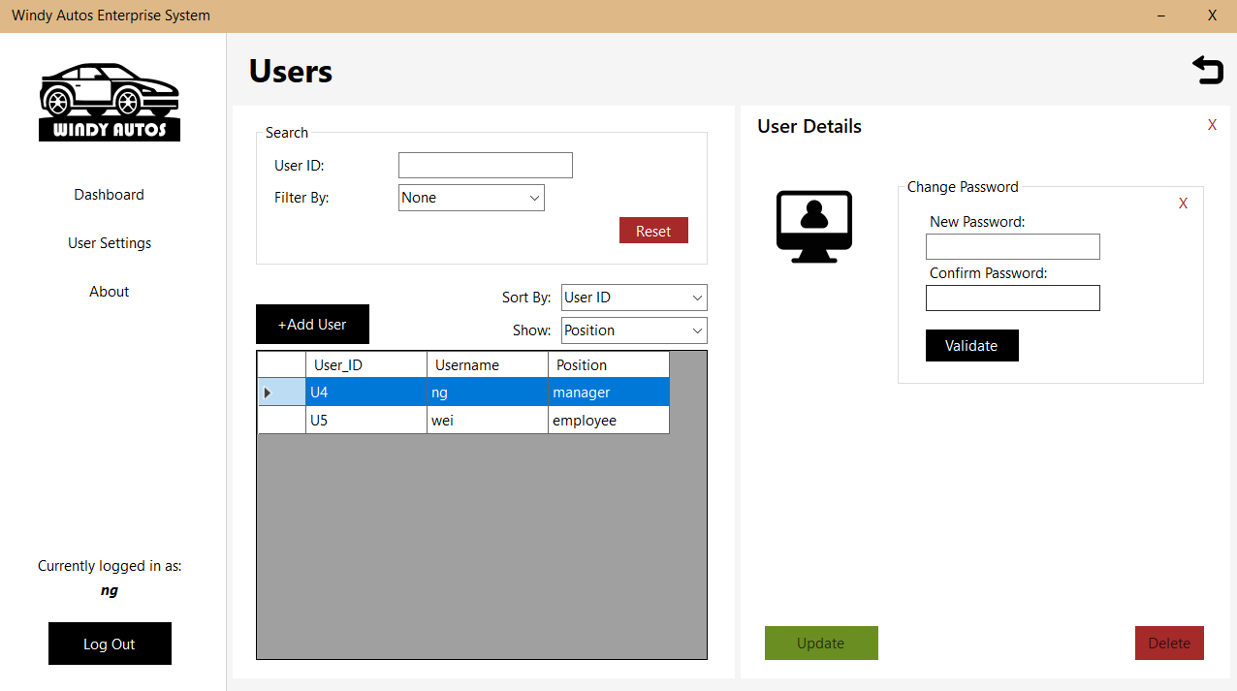

## Chapter 5.0 Testing and Future Enhancement

#### Testing

To ensure the system functions as expected, thorough testing was conducted at different stages of development. Given that Mr. Ng has no prior experience with digital record-keeping, usability was a key focus throughout the testing process. The goal was to verify that all features met the requirements while maintaining an intuitive user experience.

Testing was divided into several categories, each targeting a specific aspect of the system. Unit testing was performed on individual modules such as car management, customer records, and transaction processing to confirm that each component worked independently. Integration testing was then carried out to verify that different modules interacted correctly, ensuring that, for example, new customer entries could be linked to transactions and reports generated accurately.

For usability testing, Mr. Ng was asked to perform basic operations, such as adding a new car entry, recording a transaction, and generating a report. He was also tasked with retrieving

past transaction details to assess the system’s search functionality. The results highlighted a few minor usability issues, such as confusion over button placements and unclear labels, which were adjusted accordingly.

Performance testing ensured the system could handle an increasing number of records without significant slowdowns. Given that Windy Autos is a small business, the database was not expected to grow excessively, but optimizations were made to keep operations smooth even with thousands of records.

By the end of testing, the system was deemed fully functional, with no major defects. Any minor issues identified were corrected, and the system was prepared for deployment.

#### Future Enhancements

While the system meets all initial requirements, there are several areas where additional features could improve functionality and adaptability in the future. These enhancements would further streamline operations and make the system more versatile for potential business growth.

One possible improvement is the expansion of user roles. Currently, the system is designed with Mr. Ng as the sole user, but in the event that Windy Autos grows and hires additional staff, a more detailed role-based access system could be implemented. This could include different permission levels, such as a salesperson role with limited access to sensitive financial data or an accountant role with access to reports but no ability to modify inventory.

Another enhancement could involve support for multiple devices. The current system is designed for use on a desktop or laptop, but adding compatibility for tablets or mobile devices would give Mr. Ng more flexibility. This would allow him to check inventory or review transactions even when away from the dealership.

A customizable user interface (UI) could be another valuable addition. While the current design is straightforward, allowing Mr. Ng to personalize aspects such as color themes, font sizes, or dashboard layout could enhance usability, particularly if additional employees are introduced who have different preferences.

Further improvements could also include customizable settings with presets. Instead of requiring manual input for each transaction or report, the system could offer preset templates for frequently used operations. For example, if Mr. Ng frequently sells vehicles with a specific financing plan, a preset could automatically fill in standard values, reducing manual work.

Expanding the analytics and reporting features would be another logical step. While the system already provides basic reports on sales and transactions, future updates could introduce more detailed performance metrics, such as sales trends over time, customer purchasing behavior, or profitability forecasts. These insights could help Mr. Ng make more informed business decisions.

Additionally, automated data backups could be introduced to further safeguard information. While the system currently requires manual backups, an automated process could ensure that data is regularly saved to an external drive or cloud storage, reducing the risk of data loss.

These enhancements are not necessary for the current operation of Windy Autos, but as the business evolves, they could significantly improve efficiency and adaptability. Future updates will depend on Mr. Ng’s needs and willingness to integrate additional functionalities into his workflow.

## Chapter 6.0 Conclusion

Developing this system for Windy Autos has been a challenging yet rewarding experience. From the initial requirement gathering to final testing, every stage of the project presented its own set of difficulties, forcing me to adapt, troubleshoot, and think critically. Working on a

real-world application highlighted the gap between theoretical knowledge and practical implementation, pushing me to refine my problem-solving skills in ways that coursework alone could not.

One of the biggest takeaways from this project was the importance of debugging—not just as a technical process but as a mindset. Debugging is more than fixing errors; it requires patience, logical reasoning, and a systematic approach to identifying problems. Often, a single issue in the system had multiple possible causes, and tracking down the root of the problem involved more than just reading error messages—it meant stepping back, analyzing patterns, and thinking from different perspectives. This experience reinforced the idea that problem-solving in IT is rarely straightforward, and persistence is just as important as technical knowledge.

Another key lesson was understanding the user’s perspective. Designing a system that works is one thing, but designing a system that is usable is another challenge entirely. Mr. Ng’s limited familiarity with technology made it clear that usability could not be an afterthought. Labels, button placements, and workflow efficiency all played a role in making the system intuitive, and usability testing was essential in refining these details. This experience taught me that technical proficiency alone is not enough; understanding the end-user's needs and limitations is just as critical in software development.

Additionally, working on this project provided a glimpse into the broader responsibilities of an IT professional. Software development is not just about writing code—it involves planning, analysis, design, testing, and continuous refinement. Creating a functional system required a structured approach, from defining clear requirements to implementing security measures and ensuring proper documentation. This reinforced the idea that software development is a process of iteration and improvement, not just a one-time task.

Ultimately, seeing the completed system functioning as intended was a fulfilling moment. The initial uncertainties, the frustrating bugs, and the countless revisions all culminated in a working solution that addressed a real problem. This sense of accomplishment reaffirmed my interest in the IT field, showing me that despite the inevitable challenges, solving problems and creating meaningful solutions is what makes this field exciting.

This project has been a learning experience in every sense, strengthening both my technical and analytical skills. It has given me a deeper appreciation for the complexities of software

development and has prepared me for future challenges in the industry. While there will always be more to learn, this experience has laid a solid foundation, and I look forward to applying these lessons in future projects.

## Chapter 7.0 References

* Portny, S. E. (2022). Project Management For Dummies 6th Ed. John Wiley & Sons.
* Jeffrey A. Hoffer, Joey F. George, Joseph S.Valacich (2017) Modern Systems Analysis and Design 8/e, Pearson Education
* Systems Analysis and Design – Ninth Edition, by Shelly, Cashman, & Rosenblatt (Thomson Course Technology - 2012)
* C# Fundamentals - Getting Started with C# 11 and .NET 7 by Adam Seebebeck - 2023
* Kalchthaler, A. (2021). The Gap Between The Theory Of Database Design And Real- World Practices: How To End: Relational Database Design And Implementation. Addition-Wesley Professional
* Hernandez, M. J. (2020). Database Design for Mere Mortals. Addison-Wesley Professional; 4th edition.

## Chapter 8.0 Appendix

Log Reports

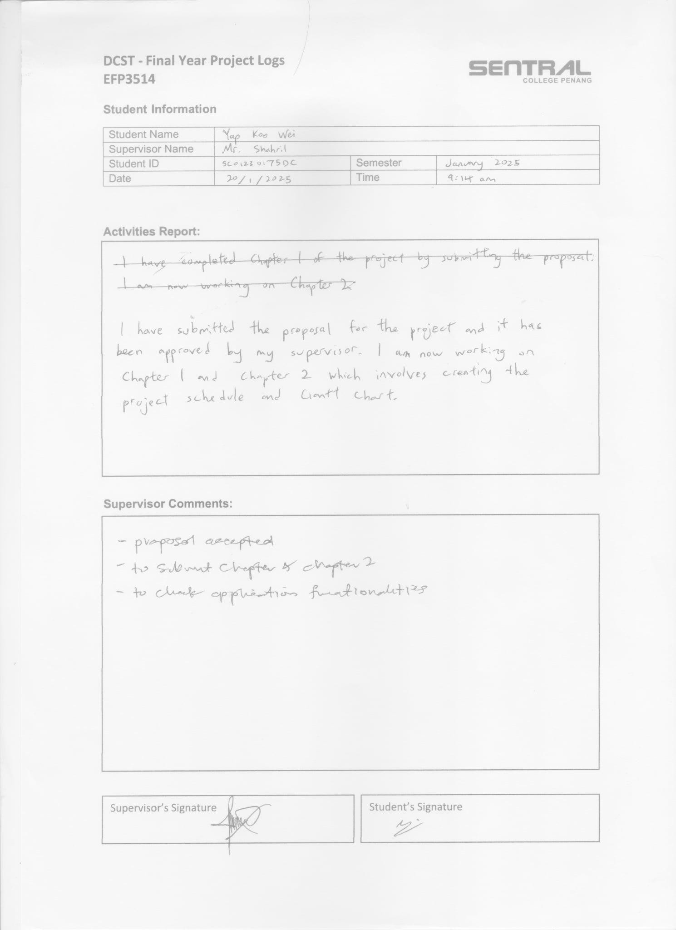

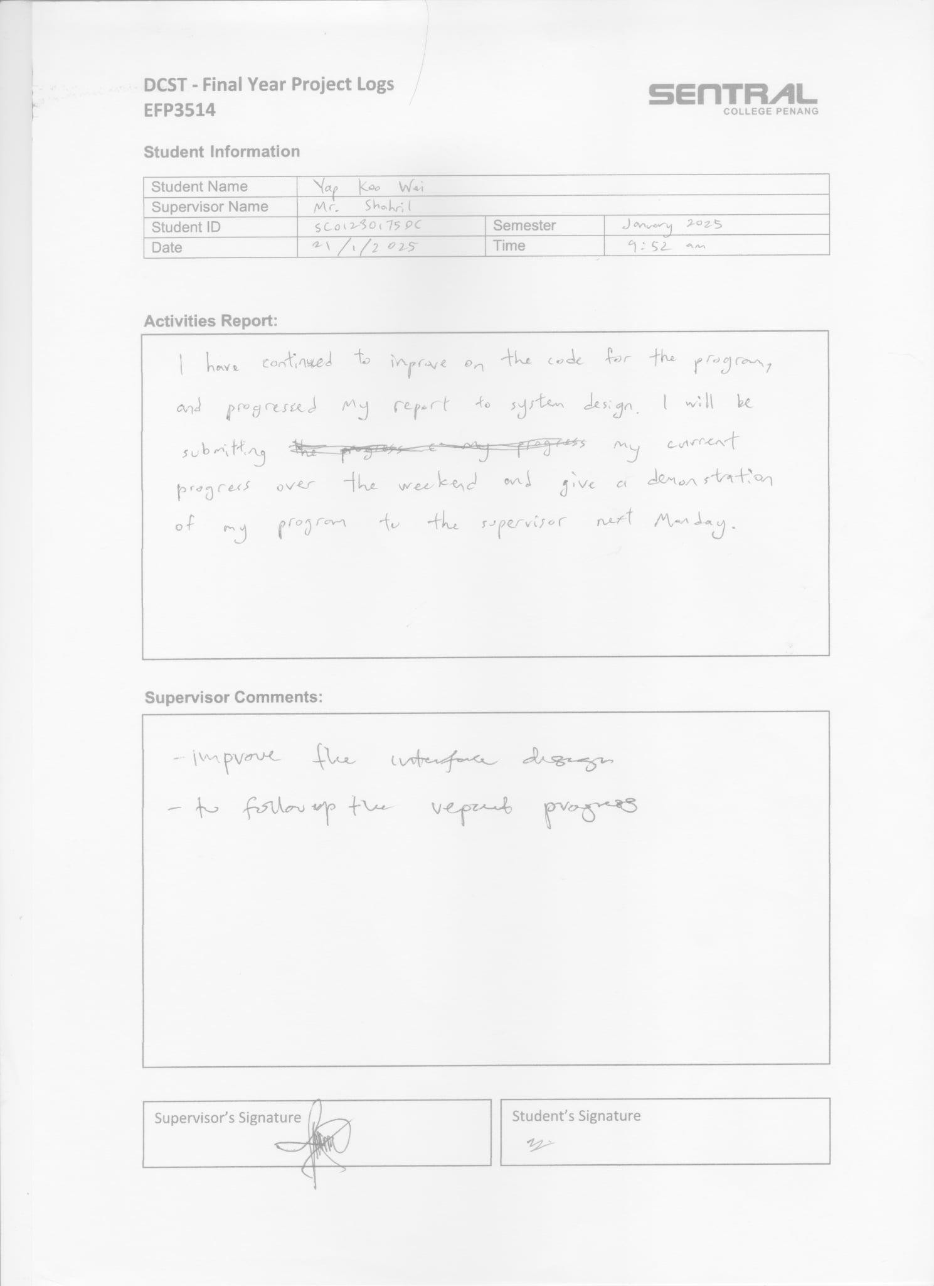

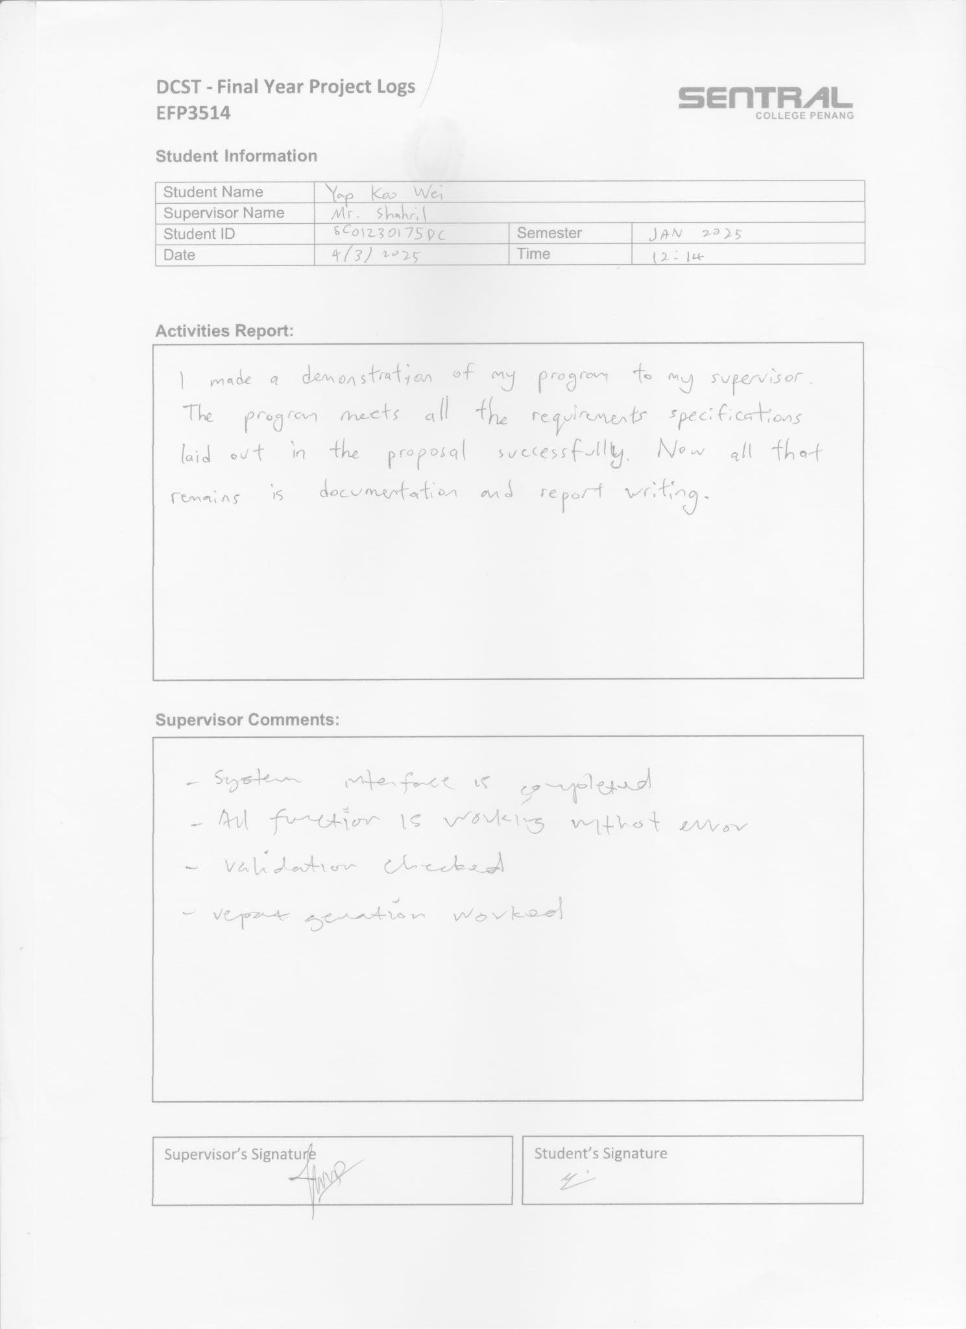

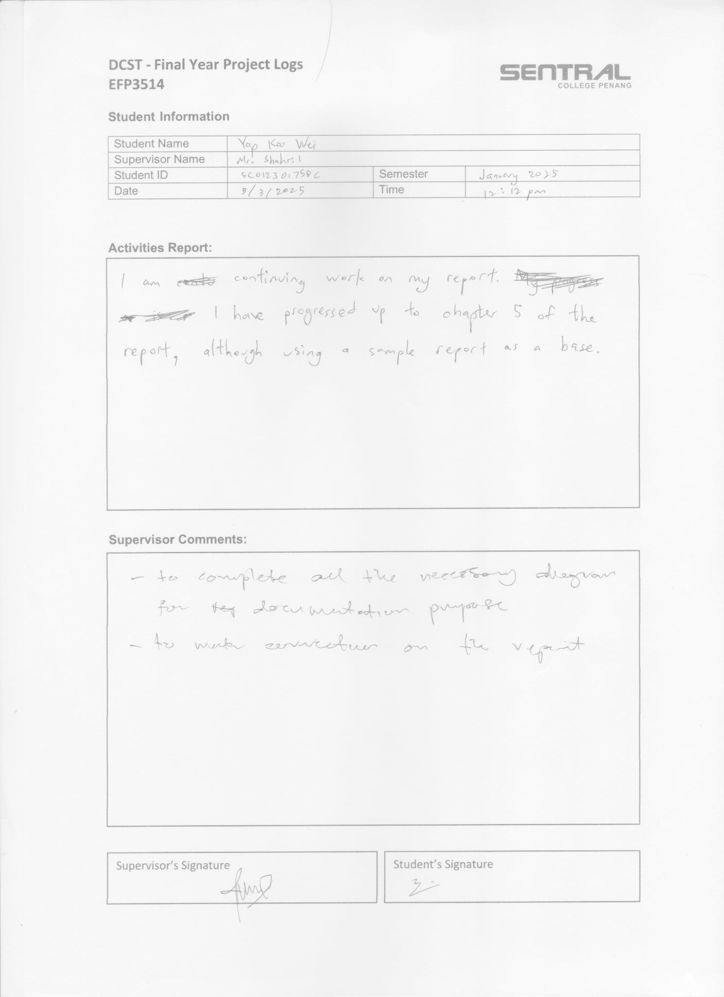

### A green and white logo AI-generated content may be incorrect.DCST - Final Year Project Logs EFP3514

**Student Information**

|  |  |  |  |
| --- | --- | --- | --- |
| Student Name | Yap Koo Wei | | |
| Supervisor Name | Mr. Shahril | | |
| Student ID | SC01230175DC | Semester | January 2025 |
| Date | 7/3/2025 | Time | 3:26PM |

**Activities Report:**

I have completed the project presentation with the supervisors’ unanimous approval of my work. I will now finish the final details of my report.

**Supervisor Comments:**

|  |  |  |
| --- | --- | --- |
|  | | |
| Supervisor’s Signature |  | Student’s Signature |
|  |  |  |

### A green and white logo AI-generated content may be incorrect.DCST - Final Year Project Logs EFP3514

**Student Information**

|  |  |  |  |
| --- | --- | --- | --- |
| Student Name | Yap Koo Wei | | |
| Supervisor Name | Mr. Shahril | | |
| Student ID | SC01230175DC | Semester | January 2025 |
| Date | 8/3/2025 | Time | 3:26PM |

**Activities Report:**

I have finish the final details of my report, and I will prepare to submit the draft to my supervisor.

**Supervisor Comments:**

|  |  |  |
| --- | --- | --- |
|  | | |
| Supervisor’s Signature |  | Student’s Signature |
|  |  |  |

11

**Appendix C**

### DCST - Final Year Project – Rubric (Supervisor)

|  |  |
| --- | --- |
| Student Name: |  |
| Student ID: |  |
| Project Title: |  |
| Academic Semester: |  |

|  |  |  |  |  |  |  |
| --- | --- | --- | --- | --- | --- | --- |
|  | **Poor** | **Fair** | **Average** | **Good** | **Excellent** |  |
| **Criteria** |  |  |  |  |  | **Max**  **Marks** |
| Problem Statement - Proposal (10%) | Blurred problem statement or inappropriate/irrelevant problem statement  (0%-2%) | Lack of justification on the problem statement and incomplete (3%-4%) | Complete problem statement with brief justification presented.  (5% - 6%) | Complete problem statement with clear justification. (7% -8%) | Problem statement clearly written with complete justification. (9% -10%) | 10 |
| Marks |  |  |  |  |  |  |
| System Analysis & Design (30%) | Poor analysis contents, with very little design diagrams (0% - 6%) | Fairly clear but doubtful analysis with system design methodologies  (7% - 12%) | Relatively clear analysis with system design methodologies (13% - 18%) | Clear analysis with consistency in system design (19% - 24%) | Outstanding analysis with clear system design (25% -  30%) | 30 |
| Marks |  |  |  |  |  |  |
| Development (20%) | Poor in coding, fail to integrate the entire system component, No validations on data and no adherence to standard naming conventions.  (0% - 4%) | Fair code development with partly component developed, minimal validations on data and apply partly to standard naming conventions.  (5%-9%) | Complete coding with major component developed, acceptable validations with proper naming conventions (10% - 12%) | Complete coding with major component developed, with proper validations but inconsistent in naming conventions (13% - 16%) | Outstanding code development with fully developed component and appropriate validations and naming conventions that is consistent.  (17% -20%) | 20 |
| Marks |  |  |  |  |  |  |
| Documentation (30%) | Poor contents, without justifications and incomplete  (0% - 6%) | Fairly clear, reasonable but doubtful and inconsistency  (7%-12%) | Relatively clear and reasonable but lack of consistency (13% - 18%) | Clear, complete and consistent with the format of documentations  (19% - 24%) | Outstanding documentations with very consistent manner  (25% -30%) | 30 |
| Marks |  |  |  |  |  |  |

Remarks:

12

### DCST - Final Year Project – Rubric (2nd Marker)

**Appendix D**

|  |  |
| --- | --- |
| Student Name: |  |
| Student ID: |  |
| Project Title: |  |
| Academic Semester: |  |

|  |  |  |  |  |  |  |
| --- | --- | --- | --- | --- | --- | --- |
|  | **Poor** | **Fair** | **Average** | **Good** | **Excellent** |  |
| **Criteria** |  |  |  |  |  | **Max**  **Marks** |
| Problem Statement - Proposal (10%) | Blurred problem statement or inappropriate/irrelevant problem statement  (0%-2%) | Lack of justification on the problem statement and incomplete (3%-4%) | Complete problem statement with brief justification presented.  (5% - 6%) | Complete problem statement with clear justification. (7% -8%) | Problem statement clearly written with complete justification. (9% -10%) | 10 |
| Marks |  |  |  |  |  |  |
| System Analysis & Design (30%) | Poor analysis contents, with very little design diagrams (0% - 6%) | Fairly clear but doubtful analysis with system design methodologies  (7% - 12%) | Relatively clear analysis with system design methodologies (13% - 18%) | Clear analysis with consistency in system design (19% - 24%) | Outstanding analysis with clear system design (25% -  30%) | 30 |
| Marks |  |  |  |  |  |  |
| Development (20%) | Poor in coding, fail to integrate the entire system component, No validations on data and no adherence to standard naming conventions.  (0% - 4%) | Fair code development with partly component developed, minimal validations on data and apply partly to standard naming conventions.  (5%-9%) | Complete coding with major component developed, acceptable validations with proper naming conventions (10% - 12%) | Complete coding with major component developed, with proper validations but inconsistent in naming conventions (13% - 16%) | Outstanding code development with fully developed component and appropriate validations and naming conventions that is consistent.  (17% -20%) | 20 |
| Marks |  |  |  |  |  |  |
| Documentation (30%) | Poor contents, without justifications and incomplete  (0% - 6%) | Fairly clear, reasonable but doubtful and inconsistency  (7%-12%) | Relatively clear and reasonable but lack of consistency (13% - 18%) | Clear, complete and consistent with the format of documentations  (19% - 24%) | Outstanding documentations with very consistent manner  (25% -30%) | 30 |
| Marks |  |  |  |  |  |  |

Remarks:

13

**PRESENTATION MARKING RUBRICS Appendix E**

|  |  |  |  |  |  |  |
| --- | --- | --- | --- | --- | --- | --- |
|  | **Poor** | **Average** | **Good** | **Excellent** | **Marks** | **Remarks** |
| **Criteria** | 1-5 | 6-10 | 11-15 | 16-20 |
| **Subject Knowledge (content)** | Student does not have grasp of information and cannot answer questions about subject. | Student is uncomfortable with information and is able to answer only rudimentary questions. | Student is at ease with expected answers to all questions, but fails to elaborate. | Student demonstrates full knowledge (more than required) with précised explanations and elaborations. | /20 |  |
| **Interaction with audience** | Student barely interacted with audience and only talks in front. | Student tries to interact but do not wait for response from audience. | Student interacts with audience and has some response. | Student interacts and encourages response from the audience. | /20 |  |
| **Text and Graphics (Slides Preparation)** | Student uses superfluous graphics or no graphics and inappropriate text. | Student occasionally uses graphics but rarely support text and presentation. | Student’s graphics relate to text and presentation and readable text. | Student’s graphics explain and reinforce screen text and presentation with appropriate text. | /20 |  |
| **Speaking**  **/Presentation Skills** | Speaking inaudible or too loud; no eye contact; back to audience most of time; speaker seemed completely uninterested | Speaking inaudible or too loud; very little eye contact; speaker seemed uninterested | Some mumbling; volume uneven; little eye contact  or enthusiasm | Poised, clear articulation; proper volume;  good eye  contact; enthusiastic; confident | /20 |  |
| **Organization of Presentation** | Audience cannot understand because there is no sequence of information. | Audience has difficulty following presentation because student jumps around. | Student presents information in logical sequence which audience can follow. | Student presents information in logical interesting sequence which audience can follow. | /20 |  |

# /100% | /10%

14

**Appendix F**



### EFP3514/Final Year Project – Overall Marksheet

Student Name:

Student ID:

Project Title:

|  |  |  |  |  |  |
| --- | --- | --- | --- | --- | --- |
| **Criteria** | **Supervisor** | **2nd Marker** | **Total**  **Marks** | **Max**  **Marks** | **Average** |
| Name: | Name: |  |  |  |
| Problem Statement  -Proposal (10%) |  |  |  | 20 |  |
| System Analysis and Design (30%) |  |  |  | 60 |  |
| Development (20%) |  |  |  | 40 |  |
| Project  Documentation (30%) |  |  |  | 60 |  |
| Presentation (10%) |  | **----** |  | 10 |  |
| **Signature** |  |  |  | **Total :** |  |

Additional Comments:

Project Proposal



EFP3514 – Final Year Project

**PROJECT PROPOSAL FORM**

**Student Name: YAP KOO WEI**

**Student ID: SC01230175DC**

**Contact Number: 01136454384**

**E-mail:** [**sc01230175dc@sentral.edu.my**](mailto:sc01230175dc@sentral.edu.my) **Project Title: Windy Autos Management System Project Category: Enterprise Systems**

1. Introduction of the Project

Windy Autos is a used car dealership in Bukit Mertajam. The business owner and sole worker, Mr. Ng, stores data on paper, and he finds it difficult to keep track of all the information on cars in stock, the information on customers, as well as to manually record transactions and calculations for accounting purposes.

Mr. Ng prefers not to hire an additional employee to help, so he is seeking a digital solution. He wants a convenient and centralized way to store and access data, and to improve the general flow of business.

1. Aims of the Project

The aim of this project is to develop an application for Mr. Ng that addresses the difficulties he currently faces running his business. The system should first and foremost have all the functionalities according to his requirements, which are to add, edit, and delete entries in the database, automatically record and calculate transactional data which can be pulled from to

create a custom report.

The benefits of which are to reduce the likelihood of human error, reduce Mr. Ng’s workload so he can better focus on servicing customers, and to improve the general flow of business.

The application itself should be intuitive and user-friendly.

1. Objectives for the Project The objectives of this project are to:

* Design, implement and test a system to meet the proposal requirements including:
  + Functional requirements specification
  + System design
  + Development
  + Testing
* Evaluate the above system
* Critically evaluate the performance of project against the proposal
* Write a project documentation
* Defend the project in a via presentation

1. Client Background

The client is Mr. Ng, currently 56 years old. He is the owner of Windy Autos, a used car dealership in Bukit Mertajam; it opens every day of the week, from 9am to 9pm. Customers who wish to make a purchase may either pay cash up-front or take out a loan from a partnered bank and pay in instalments. Optionally, customers may request to buy insurance.

Mr. Ng has been the sole worker of the business ever since its founding in 2015. He professes that his is expertise is in talking to the customers, so he would rather focus his efforts there instead of paperwork.

He previously used a traditional method to store data, but he finds the method cumbersome and prone to error. Since he does not wish to hire additional employees, he decides to utilize a modern alternative by seeking digital solution. Mr. Ng has no previous experience with technology, but he is willing to be open-minded to it.

1. Problem Statement

#### Difficulty keeping track of data

Data may be hard to find, easy to lose. Physically writing down and updating data may be hard in the first place. The traditional method is easy to lead to errors and redundancies.

#### Having to manually record transactional data

Mr. Ng finds the paperwork involved in validating a transaction to be cumbersome, as he prefers to focus his efforts on talking to customers.

#### High likelihood of error when manually calculating accounting data

Mr. Ng relies on a calculator to manually calculate all the accounting data. Having to calculate so many things by himself creates opportunities for human error. For a business, any errors can be costly.

#### No report generation

Mr. Ng has no way to conveniently generate custom reports based on past data of his business.

1. Proposed Solutions

#### Digital database

Fully digital database for Mr. Ng’s business. This will keep track of all relevant information for Mr. Ng.

#### Self-completing paperwork

The entire process can be automated using premade form and multiple-choice fields to save Mr. Ng a lot of time, as well as having safeguards to prevent errors. Each entry also has its own ID so it can be accessed easily once stored.

#### Automatic calculation

All relevant accounting elements are calculated automatically by the system. This greatly reduces Mr. Ng’s workload and the likelihood of error.

#### Custom report generation

Mr Ng. can generate a report based on custom criteria. Having the option to do so allows Mr. Ng to study his performance and improve his business in the future.

#### Requirements Specifications

* Administrator
  + User authentication
    - Log in
  + Information management
    - Manage cars information
      * Insert, update, delete car information directly
      * View, search car information
    - Manage customers data
      * Insert customer data (indirectly through transaction form)
      * Update, delete customer data directly
      * View, search customer data
    - Manage transaction data
      * Insert transaction data (indirectly through transaction form)
      * Delete transaction data directly
      * View, search transaction data
      * Print invoice
    - Manage user accounts
      * Insert, update, delete all user accounts
      * View, search user accounts
  + Transaction recording
    - Creates a form for user to input data
      * Self-completing (automatically fill in current date, purchase details, transaction ID)
      * Multiple choice options where applicable (payment option)
    - Print invoice
    - Print receipt
* Reporting
  + Display history of past transactions and overall performance
    - Customizable based on criteria (timeframe)
  + Print report
* Non-administrative User
  + User authentication
    - Log in
  + Information management
    - Manage cars information
      * Update car information directly
      * View, search car information
    - Manage customers data
      * Insert customer data (indirectly through transaction form)
      * Update customer data directly
      * View, search customer data
    - Manage transaction data
      * Insert transaction data (indirectly through transaction form)
      * View, search transaction data
      * Print invoice
    - Manage user accounts
      * Update, delete own user account
      * View, search user accounts
  + Transaction recording
    - Creates a form for user to input data
      * Self-completing (automatically fill in current date, purchase details, transaction ID)
      * Multiple choice options where applicable (payment option)
    - Print invoice
    - Print receipt
* Other
  + Security
    - User authentication required
    - Limited access for non-administrative users

#### Software Environment Required:

* + - Microsoft Visual Studio
    - SQL Server Management Studio

#### Programming Languages / Development Tools / Techniques

This project will use C# and Microsoft SQL.

1. Constraints

This student has limited operational capacity using C# and Microsoft SQL and will have to learn as the application is being developed. Additionally, time is a tangible constraint over the whole project.

1. Other Resources

* Websites such as W3schools
* Tutorial videos from YouTube
* Academic knowledge from slides and textbooks provided by Sentral College
* Guidance from Mr. Halim and Mr. Shahril

Additional Feedback by Supervisor (if any):

**Signed and agreed:**

|  |  |  |  |
| --- | --- | --- | --- |
|  | ***NAME*** | ***SIGNATURE*** | ***DATE*** |
| **SUPERVISOR** |  |  |  |
| **STUDENT** | Yap Koo Wei |  | 12/9/2024 |